Submarine Cable Analysis for US Marine Renewable Energy Development

Benjamin D. Best 1

Levi F. Kilcher 2

2017-07-26  
1: EcoQuants, Santa Barbara, CA  
2: National Renewable Energy Lab, Golden, CO

Table of Contents

Executive Summary 2

Background 4

Methods 5

Study Area, Submarine Cables, Depth and Energy Data 5

Submarine Cable Avoidance Zones 7

Depth-Varying Cable Buffer 7

Results 7

Cable Buffer 8

Overlap of Cable Buffer with Renewable Energy 10

Tidal 13

Wave 15

Wind 17

Conclusions 18

(APPENDIX) Appendix 19

Detailed Maps by US Territory of Cable Buffer and Renewable Energy 19

Alaska 19

Tidal 19

Wave 20

East 21

Tidal 22

Wave 23

Wind 24

Guam 25

Gulf of Mexico 26

Tidal 27

Wave 28

Wind 29

Hawaii 30

Wave 31

Wind 32

Johnston Atoll 33

N Mariana Islands 34

Palmyra Atoll 35

Puerto Rico 36

Tidal 37

Wave 38

US Virgin Islands 39

Tidal 40

Wave 41

Wake Island 42

West 43

Tidal 44

Wave 45

Wind 46

References 47

# Executive Summary

Marine renewable energy from offshore wind, tidal and wave sources promises to diversify the U.S. renewable energy portfolio, which is important to reducing greenhouse gas emissions contributing to climate change and to decrease reliance on foreign fossil fuel markets for the sake of national security.

Marine renewable energy is:

complementary to other large scale renewables, such as solar because of offering peak demand with “duck curve”

* Complementary to other large scale renewable energy
* Predictable throughout day and seasons
* Proximity to dense coastal populations

provides access to coastal communities where populations are highest Development of these marine energy resources in the U.S. lags considerably behind Europe and other developed countries. The first (and currently only) U.S. commercial facility as a wind farm in Block Island, Rhode Island went into production December of 2016. As implementation costs for these technologies continue to drop and increasingly ambitious targets for renewable energy are set, planning of new marine renewable energy development needs to effectively consider competing ocean uses that may come into conflict.

Operation and maintenance of submarine cables may conflict with marine renewable energy development. Although submarine cable locations are publicly accessible, safe setback distances are not readily available for planning new marine renewable energy development. Repair and maintenance of cables traditionally involves grappling the cable and floating it to the surface, so allowance for drift of the repairing vessel is dependent on the depth of the water.

We applied industry-advised safety buffers that varied with depth to existing submarine cables for "minimum" (2*depth, i.e. "2z") and "recommended" (3*depth, i.e. "3z") horizontal distances, both having a minimum 500 m buffer. The cable buffer area ranged from 29.35% (242,042 km2 [3z] of 824,679 km2 total) in the West Coast region owing to many cables present and the steep continental shelf, to virtually nill 0.01% (42 km2 [2z] of 406,970 km2 total) in Wake Island (Table 2).

Overlap of cable buffers with marine renewable energy was assessed for tidal (Haas et al. 2011), wave (Jacobson et al. 2011) and offshore wind energy (Chapman et al. 2012) datasets available through the National Renewable Energy Lab (NREL) Wind Prospector[1] or MHK Atlas[2]. Generally the highest proportion of energy is in the lower classes least likely for development where the highest area of overlap with cable buffers also exist (Figure 3; Table 3).

The highest wind speed classes (10-11 & 11-12 m/s) are however also occupied by the highest percentage of cable buffer overlap (55.7% & 39.8% for 3z, 39.8% & 15.9% for 2z respectively). These uncommon high wind speed areas are limited to Hawaii and West territories, but also to areas offshore in deep waters not practically viable for energy development (Table 6; Figure 6, 21 and 35). …

Wave energy has a bimodal distribution, most abundant in the lowest class (997,570 km2 for 0-10 kW/m) with a sharp drop at the next lowest class (292,692 km2 for 0-10 kW/m) and then ramping up to roughly half the highest class (532,533 km2 for >30 kW/m). Overlap with cable buffers for the highest two classes (20-30 & >30 kW/m) is just over 5% (5.2% & 5% for 2z, 6.8% & 6.7% for 3z). Similar to wind, these high energy wave classes are limited to the Pacific territories of Hawaii, West and Alaska (wind for Alaska was not available) (Table 5; Figure 5 for bargraph; Figure 20 for Hawaii wave map; Figure 34 for West wave map; Figure 9 for Alaska wave map).

The cable overlap for tidal energy sites is 20.1% (12 of 59 km2) for low-intensity sites (500-1,000 W/m2) and less than 3% for the the most energetic sites with power densities >1,000 W/m2.

The proposed avoidance areas should be deemed advisory. Overlap with recommended or even minimum avoidance area does not nullify the possibility of renewable energy development there. Rather, it should alert the developer to contact the cable industry and negotiate reasonable terms. These avoidance zones are advised according to traditional methods of submarine cable repair involving grappling of the submarine cable and buoying to the surface for repair, hence allowance for sway of boat as a function of depth. In future, remotely operated vehicles may narrow safe operating distances.

These avoidance areas are limited to the most recent submarine cable data used to generate them, which is 2012 for this report. In future, more current areas of avoidance could be extracted from electronic navigation charts, which get updated more regularly.

# Background

Demand for abundant and diverse resources in the oceans is growing, which is emphasizing the importance of marine spatial planning. To inform development of Marine Hydrokinetic (MHK) and Offshore Wind (OSW) resources, the Department of Energy (DOE), NREL, and EcoQuants, LLC have undertaken this competing uses analysis between MHK/OSW technologies and submarine power/telecom cables. The first step in this work is to identify and quantify the overlap between the MHK/OSW resource availability and existing cable routes.

[

Terms:

* spatial separation scheme
  + Default and Minimum Separation Distances

Status of:

* All US: 100% clean and renewable wind, water, and sunlight (WWS) all-sector energy roadmaps for the 50 United States [@z.jacobson_100_2015]
  + possible to achieve  
    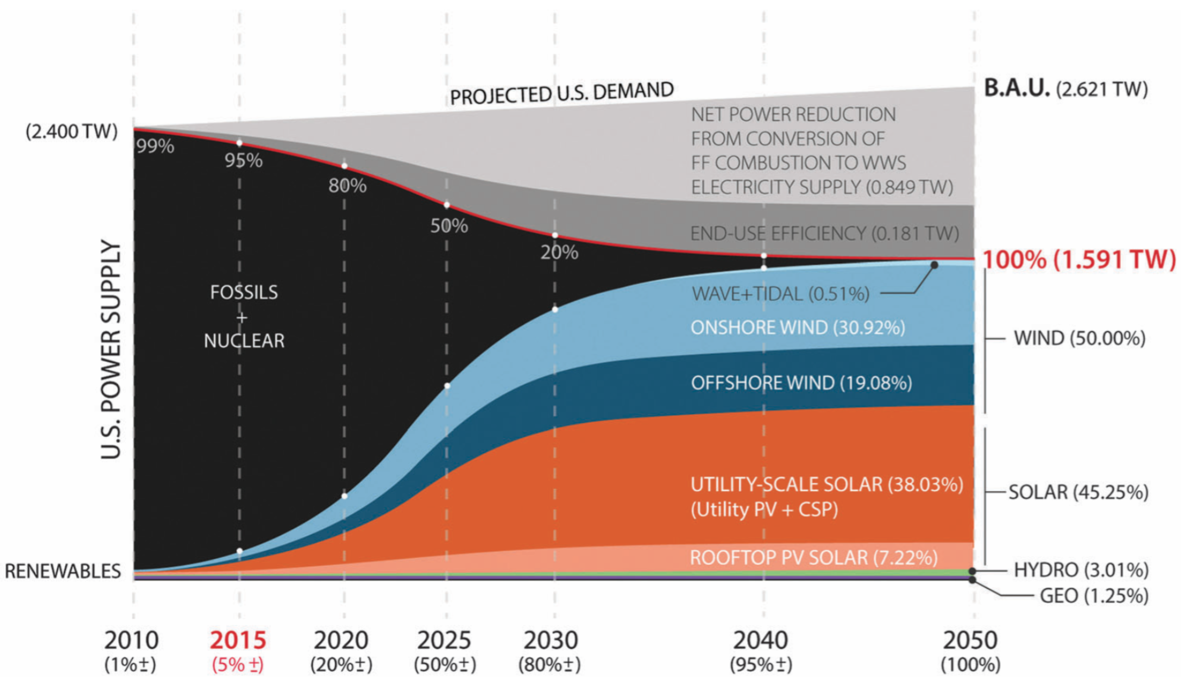
  + eg CA & HI with most aggressive RPS includes mix of offshore wind, wave, tidal:  
    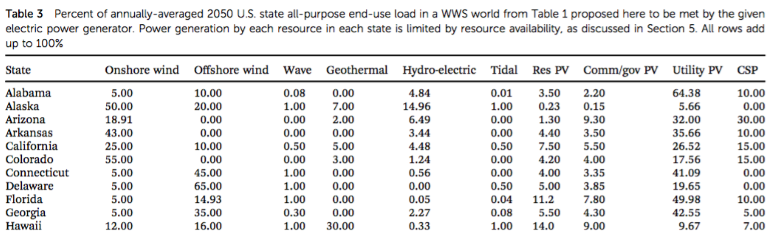
* Tidal & Wave:
  + Wave and tidal current energy – A review of the current state of research beyond technology [@uihlein_wave_2016b]
  + Ocean wave energy in the United States: Current status and future perspectives [@lehmann_ocean_2017a]
    - 5. Open source databases, simulation and reference models
    - tidal and wave in world  
      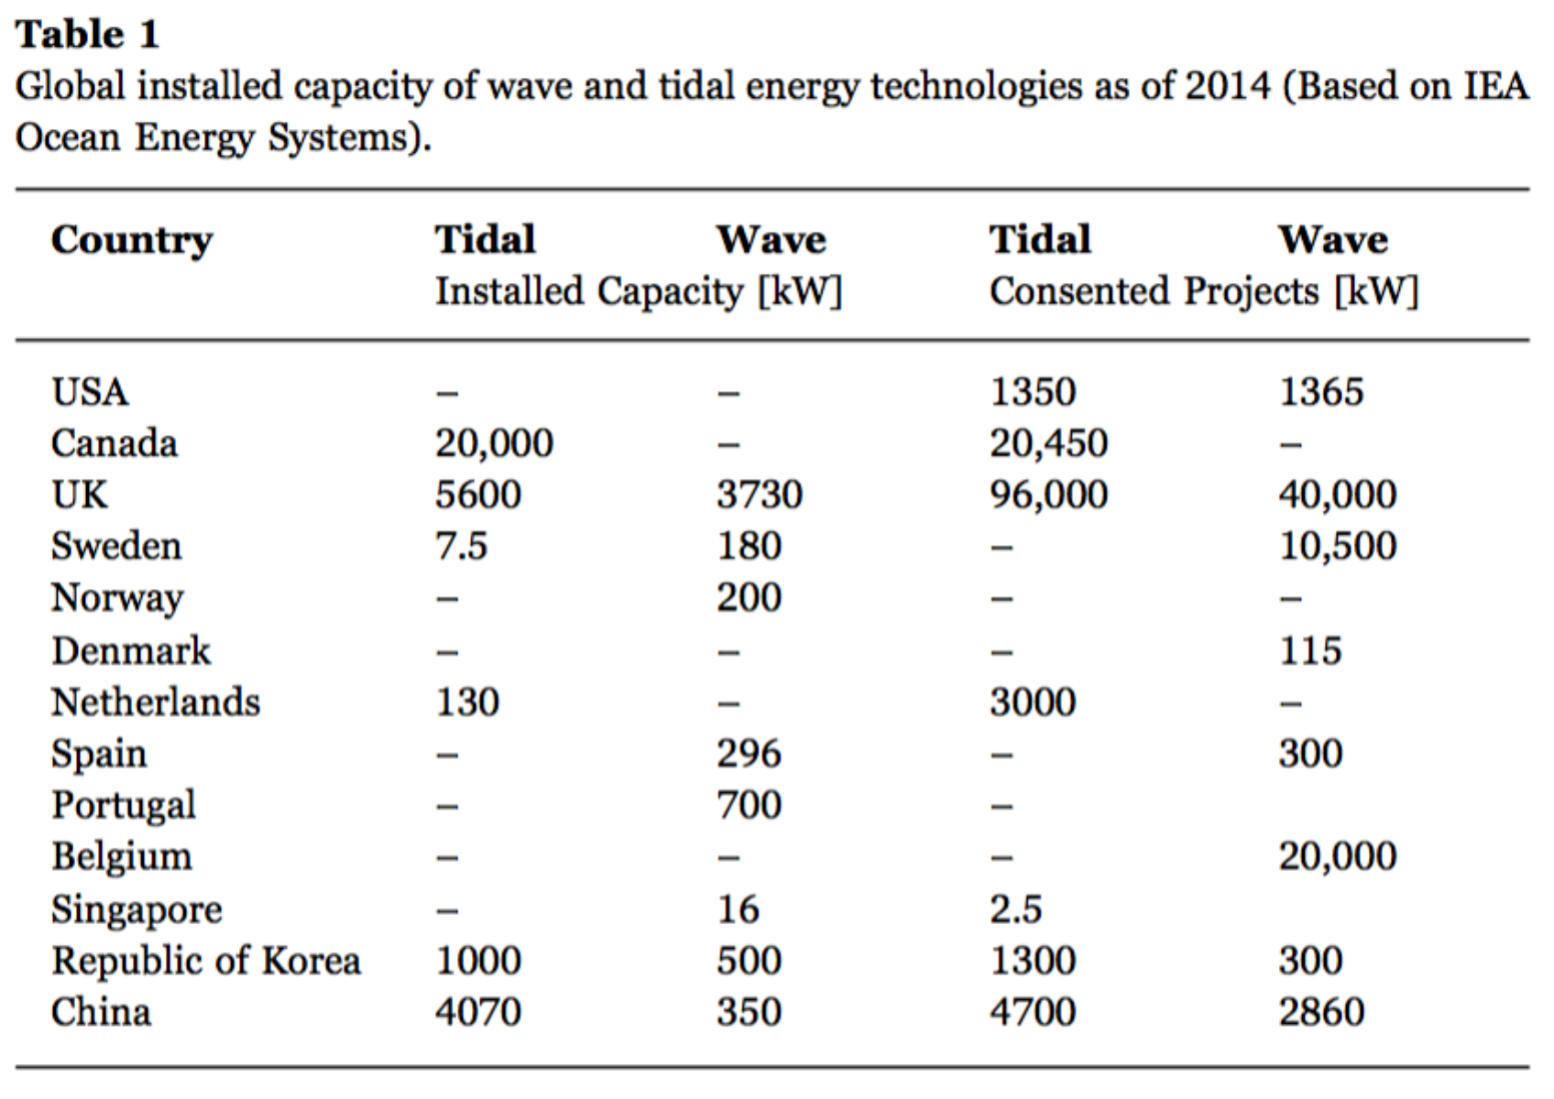
* Tidal:
  + Status of wave and tidal power technologies for the United States [@musial_status_2008]

Cable install and repair:

* [Subsea Cables – Maintenance / Repair Operations | KIS-ORCA](http://www.kis-orca.eu/subsea-cables/maintenance-repair-operations#.Wb1tnNP5hE4)
* [How submarine cables are made, laid, operated and repaired | Musa Phungula | Pulse | LinkedIn](https://www.linkedin.com/pulse/20140627113841-60148923-how-submarine-cables-are-made-laid-operated-and-repaired)

Regulatory:

* FERC, FCC
* best practices. some hard rules have been contested
* Protection of Submarine Cables Through Spatial Separation [@communicationssecurityreliabilityandinteroperabilitycounciliv_protection_2014]
  + int’l law. “have due regard to cables or pipelines already in position.”
  + United Nations Convention on Law of the Sea (UNCLOS) Article 79 (Submarine Cables and Pipelines on the Continental Shelf) stipulates that: “When laying submarine cables or pipelines, states shall have due regard to cables or pipelines already in position. In particular, possibilities of repairing existing cables or pipelines shall not be prejudiced.”
  + 1884 Convention on cable protection, U.S. law provides that damaging a submarine cable—whether deliberately or through negligence—is a federal offense punishable by fine, imprisonment, or both.
    - For willful damage, U.S. law provides for a fine of up to $5,000 and/or a prison term not to exceed two years. For culpably negligent damage, U.S. law provides for a fine of up to $500 and a prison term not to exceed three months.
* National Marine Sanctuaries: cable exception. NOAA currently doesn’t have authority, but did grant MHK in OR (Alla).

Conclusion caveats:

* advisory. but desktop and marine survey should consult most recent electronic navigation charts and contact NASCA.

]

The analysis is done in terms of resource area because the task of quantifying actual impacts on available resource is a non-trivial undertaking that involves subjective decisions of identifying resource opportunities. Quantifying overlap in-terms of resource area—on the other hand—is significantly more straight forward, and useful to marine spatial planners.

Several publicly available data layers are available that identify cable routes (e.g. MarineCadastre.gov currently hosts an offshore cables geographical information system (GIS) data layer) and MHK/OSW resource density (MHK Atlas, Wind Prospector). The cable route linear features, however, do not indicate the setback distance necessary to accommodate submarine cable maintenance requirements. Industry reports (Communications Security, Reliability and Interoperability Council IV 2014, 2016) from the International Cable Protection Committee (ICPC) of the North American Submarine Cable Association (NASCA)[3] advise on setback distances that inform this analysis.

# Methods

## Study Area, Submarine Cables, Depth and Energy Data

The study area consists of the US waters (Flanders Marine Institute 2016), i.e. the 200 nm extent deemed the exclusive economic zone (EEZ). We used the offshore cable dataset "NOAA Charted Submarine cables in the United States as of December 2012" available through MarineCadastre.gov.[4] The territory of the contiguous US was divided into regions: Alaska, Hawaii, West Coast, East Coast, and Gulf of Mexico (VLIZ 2017). To accomodate territories overlapping the international dateline (Hawaii and Alaska), all input and output products were shifted from [-180,180] to [0,360]. For more details on the 12 territories used in this analysis, see Table 1 and Figure 1. Of the original 230,835 km in the cable dataset (Figure 1), 97,321 km fell within the 200 nm of the US exclusive economic zone (EEZ), which was analyzed across 12 territories that overlapped with the cables (Figure 2).

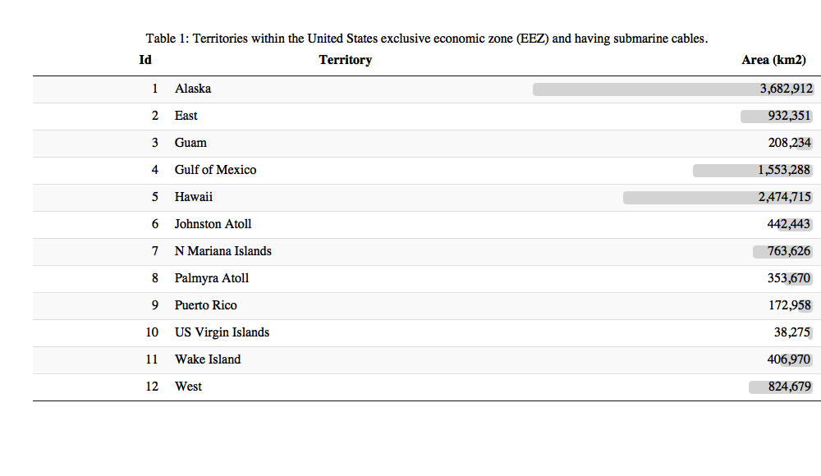

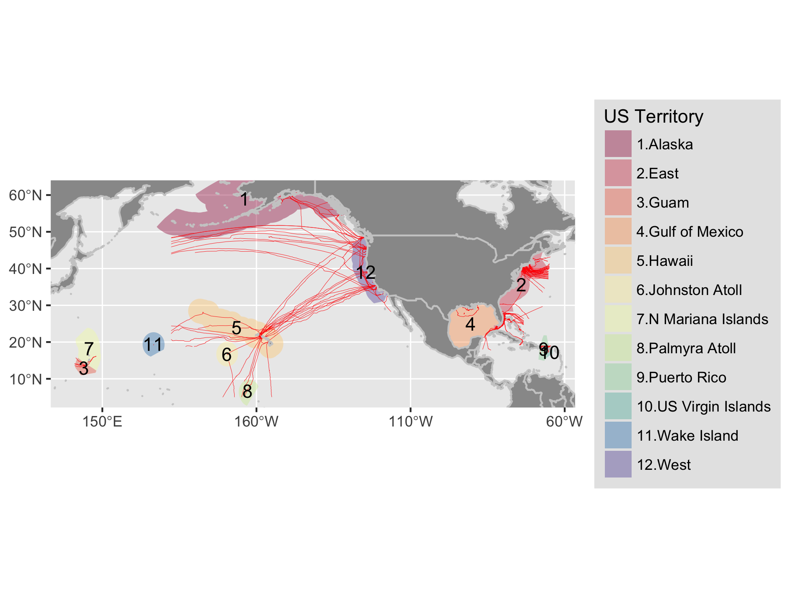

Figure 1 Map of NOAA Charted Submarine cables as of December 2012 within the exclusive economic zone (EEZ; 200 nm) of United States territories.

Bathymetric depth comes from the [GEBCO 30 arc-second grid](http://www.gebco.net/data_and_products/gridded_bathymetry_data/gebco_30_second_grid/)[5].

The marine renewable energy datasets are from NREL and accessible online via NREL's Wind Prospector[6] and MHK Atlas[7]. Tidal data were modeled using the Regional Ocean Modeling System and calibrated with available measurements of tidal current speed and water level surface in terms of watts per square meter (W/m2) (Haas et al. 2011). Wave data is based on a 51-month Wavewatch III hindcast database developed by the National Oceanographic and Atmospheric Administration’s (NOAA’s) National Centers for Environmental Prediction for estimation of wave power density in terms of kilowatts per meter (kW/m) (P. T. Jacobson et al. 2011). Wind data is for average offshore wind speed in meters per second (m/s) at a 90 m hub height (Chapman et al. 2012).[8]

## Submarine Cable Avoidance Zones

The International Cable Protection Committee (ICPC) of the North American Submarine Cable Association (NASCA) outlined recommendations for siting new offshore renewable wind energy facilities and routing new cables. For new facilities they recommend a minimum of 500 m and further offshore twice the depth to the seafloor, per ICPC Recommendation 13 No. 2 (Communications Security, Reliability and Interoperability Council IV 2014). So for depths <= 250 m, a 500 m buffer from the cables applies and for depths > 250 m, 2 * depth is to be used. For placing new submarine cables, seperation distances are specified for minimum (2 * depth) and recommended (3 * depth), per related to ICPC Recommendation 2 No. 10 (Communications Security, Reliability and Interoperability Council IV 2014). We combined these two criteria into 2 sets of buffer distances for minimum ("2z": 2 * depth) and recommended ("3z": 3 * depth) avoidance zones, both with a minimum 500 m width.

## Depth-Varying Cable Buffer

A depth-varying buffer for "minimum" (2z) and "recommended" (3z) was calculated by intersecting depth with cables and buffering the cable by depth. Depth from the GEBCO grid was reclassed into 100 m increments starting with 250 m to apply a 500 m minimum for the 2z and 3z products, and converted to polygons for intersecting with the cable linear features. A custom Albers Equal Area Conic projection based on 1/6th the extent[9] of each territory was individually applied to minimize spatial distortion when buffering.

## Reproducible Analysis with Open-Source Code

All analytical code to generate outputs, including this data driven report, are available in a publicly accessible online repository: <http://github.com/ecoquants/nrel-cables>. Here are particularly noteworthy files:

* data/
  + [lns_d1x.geojson](https://github.com/ecoquants/nrel-cables/blob/master/data/lns_d1x.geojson): lines of submarine cables segmented at 100 m increments with depth value for buffering, ie minimum 500 m and depth (z) for multiplying by 2 (2z) or 3 (3z).
  + [buf_2xdepth_incr100m.geojson](https://github.com/ecoquants/nrel-cables/blob/master/data/buf_2xdepth_incr100m.geojson): polygons for "minimum" avoidance zone for buffer at twice the depth (2z), mimimum 500 m.
  + [buf_3xdepth_incr100m.geojson](https://github.com/ecoquants/nrel-cables/blob/master/data/buf_3xdepth_incr100m.geojson): polygons for "recommended" avoidance zone for buffer at three times the depth (3z), mimimum 500 m.
* docs/
  + [packages_vars.R](https://github.com/ecoquants/nrel-cables/blob/master/docs/packages_vars.R): R code with variables and packages used across analysis (create_cable-buffer.R, extract_cable-energy.R) and reporting (report.Rmd)
  + [create_cable-buffer.R](https://github.com/ecoquants/nrel-cables/blob/master/docs/create_cable-buffer.R): R code to generate cable buffers at 100 m depth increments.
  + [extract_cable-energy.R](https://github.com/ecoquants/nrel-cables/blob/master/docs/extract_cable-energy.R): R code to extract renewable energy for cabled territories.
  + [report.Rmd](https://github.com/ecoquants/nrel-cables/blob/master/docs/report.Rmd): R markdown document for reproducible, data-driven generation of various report output file formats (report.pdf, report.docx, report.html)

# TEMP Depth Analysis

depth relevance:

* wind: <= 1,000 m [@musial_2016_2016]
* tidal: <= 100 m [@haas_assessment_2011]
* wave: <= 200 m [@Jacobson_Hagerman_Scott_2011])

# Results

## Cable Buffer

The cable buffer area ranged from 29.35% (242,042 km2 [3z] of 824,679 km2 total) in the West Coast region owing to many cables present and the steep continental shelf, to virtually nill 0.01% (42 km2 [2z] of 406,970 km2 total) in Wake Island (Table 2).

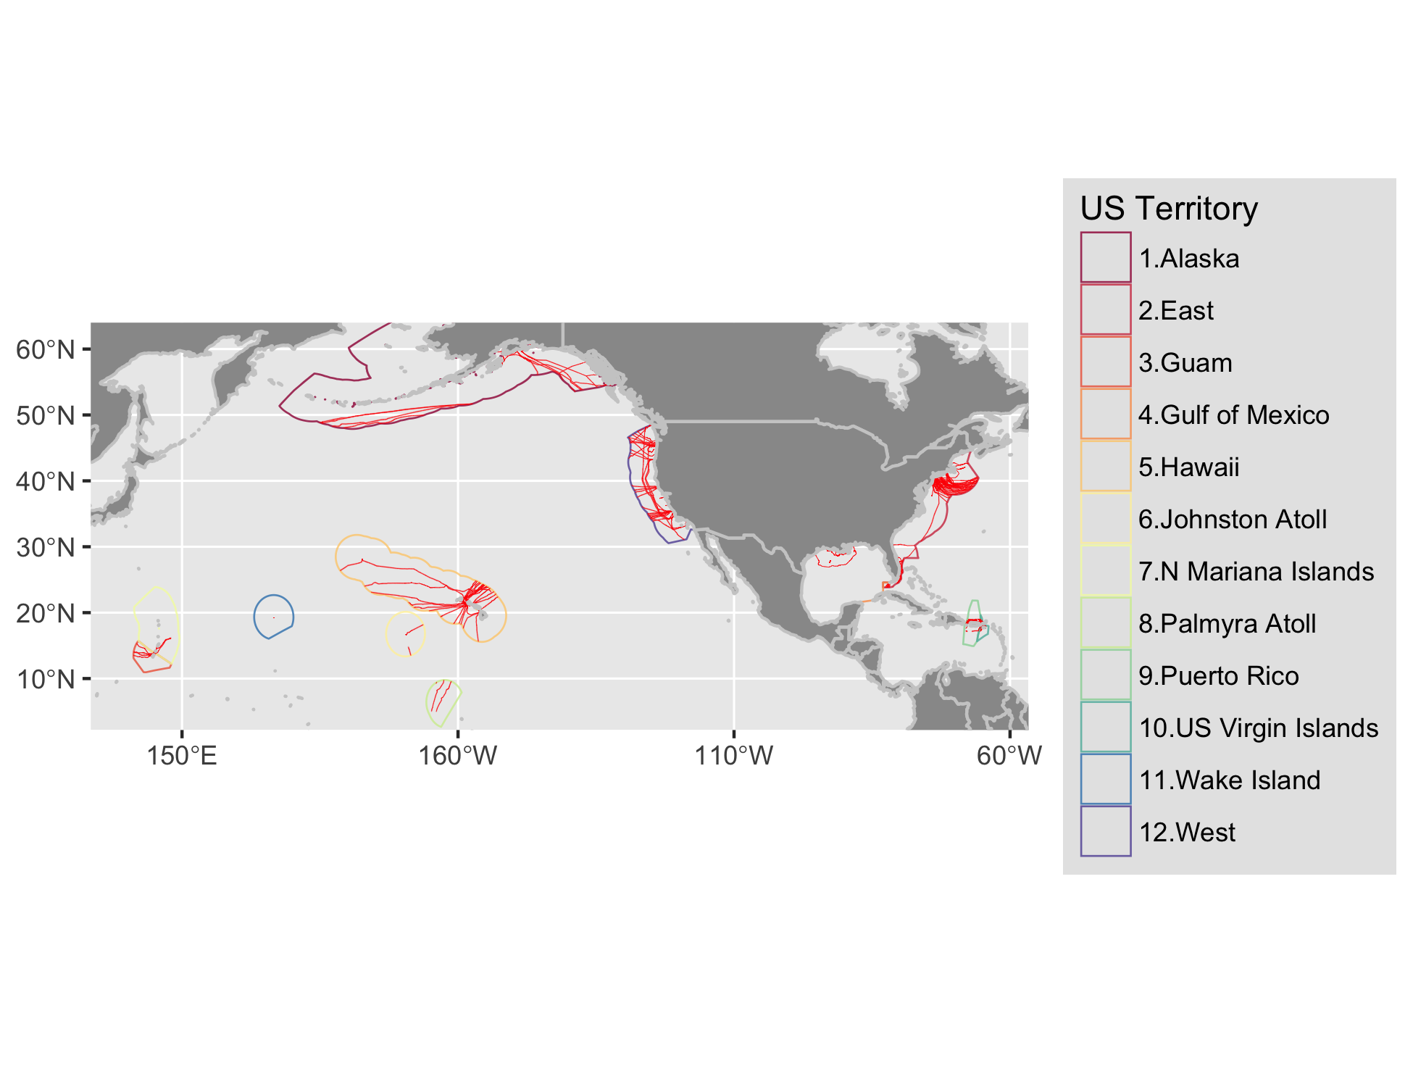

Figure 2 Map of submarine cable buffers within the exclusive economic zone (EEZ; 200 nm) of United States territories. In order to see the area covered by the buffers, please visit the Detailed Maps section.

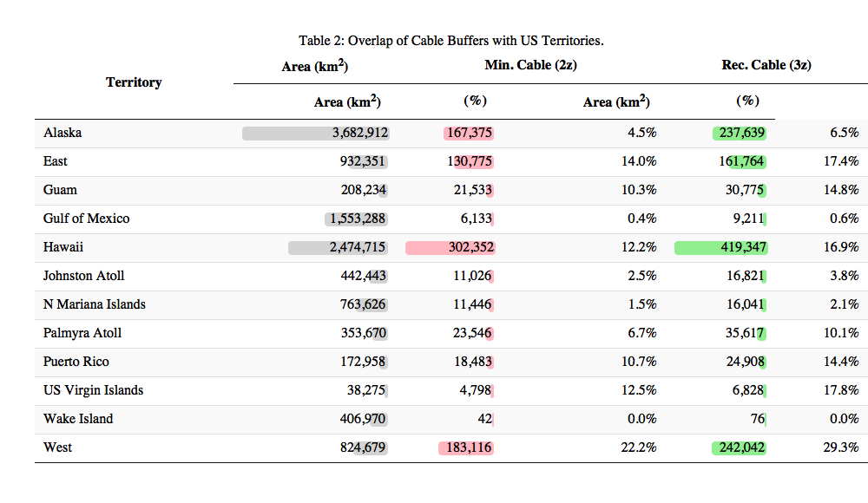

## Overlap of Cable Buffer with Renewable Energy

Generally the highest proportion of energy is in the lower classes least likely for development where the highest area of overlap with cable buffers also exist (Figure 3; Table 3). The highest wind speed classes (10-11 & 11-12 m/s) are however also occupied by the highest percentage of cable buffer overlap (55.7% & 39.8% for 3z, 39.8% & 15.9% for 2z respectively). These uncommon high wind speed areas are limited to Hawaii and West territories (Table 6; Figure 6 for bargraph; Figure 21 for Hawaii wind map; Figure 35 for West wind map). Overall wave energy has a bimodal distribution, most abundant in the lowest class (997,570 km2 for 0-10 kW/m) with a sharp drop at the next lowest class (292,692 km2 for 0-10 kW/m) and then ramping up to roughly half the highest class (532,533 km2 for >30 kW/m). Overlap with cable buffers for the highest two classes (20-30 & >30 kW/m) is just over 5% (5.2% & 5% for 2z, 6.8% & 6.7% for 3z). Similar to wind, these high energy wave classes are limited to the Pacific territories of Hawaii, West and Alaska (wind for Alaska was not available) (Table 5; Figure 5 for bargraph; Figure 20 for Hawaii wave map; Figure 34 for West wave map; Figure 9 for Alaska wave map). Tidal power is extremely dominated by the lowest energy class of 0-500 W/m2 covering 403,781 km2, which is 99.6% of the total area assessed. The cable overlap for the rare higher energy areas is at most 20.1% (12 of 59 km2) for 500-1,000 W/m2 in the West and less than 3% for the even rarer higher energy classes of 1,000-1,500 or >1,500 found only in Alaska or the East.

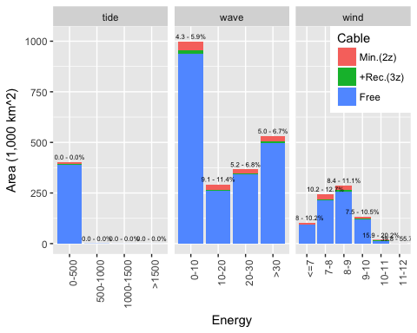

Figure 3 Energy by area and power class per US territory with cable overlay (minimum - recommended %).

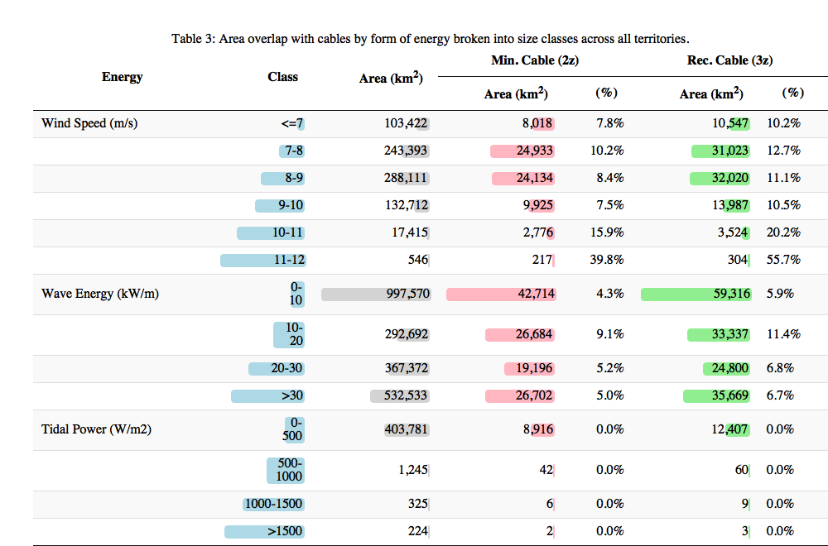

### Tidal

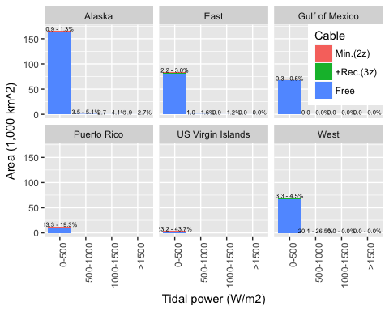

Figure 4 Tidal power (W/m2) and area per US territory with cable overlay (minimum - recommended %).

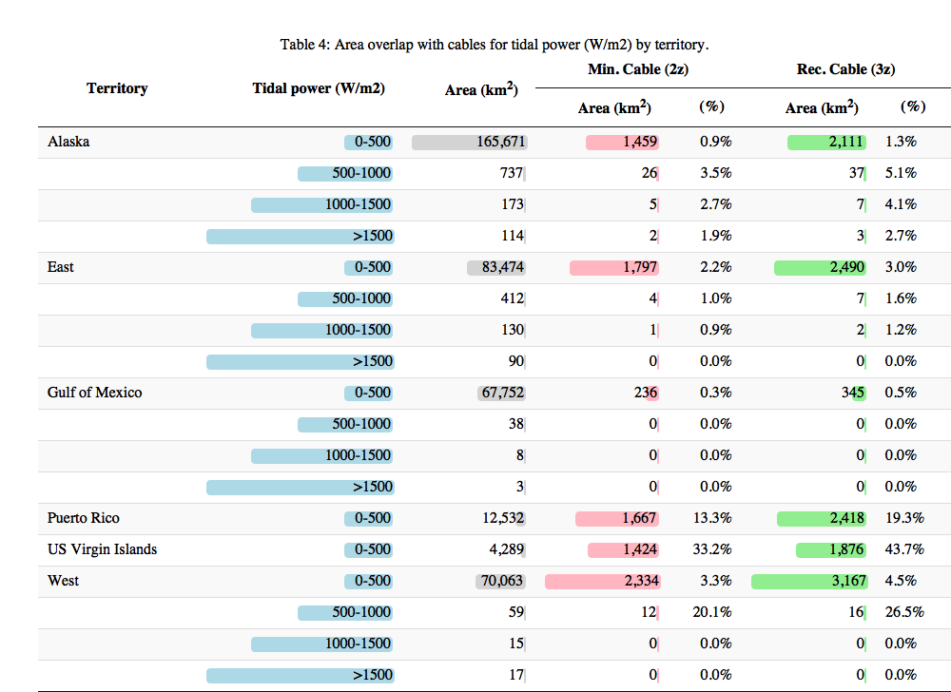

### Wave

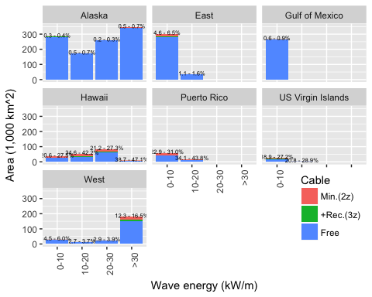

Figure 5 Wave energy (kW/m) and area per US territory with cable overlay (minimum - recommended %).

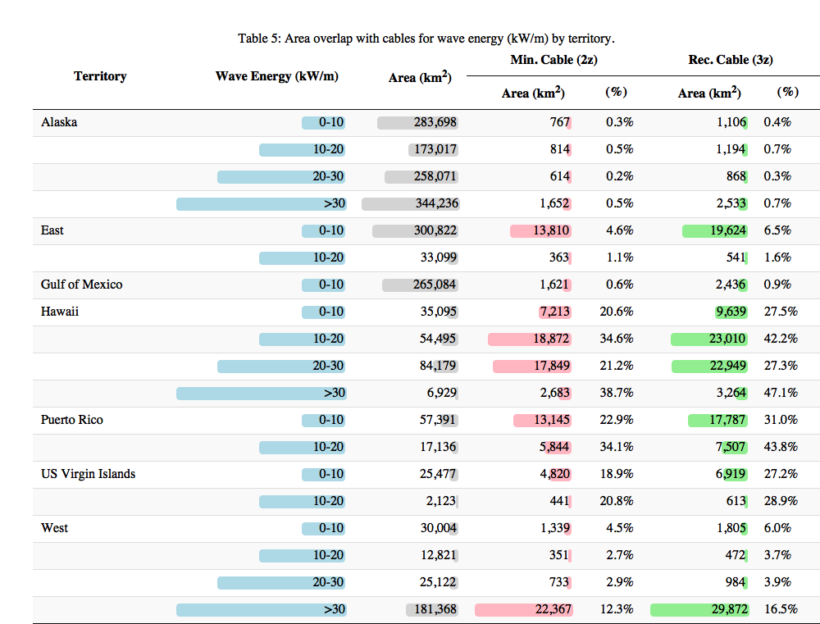

### Wind

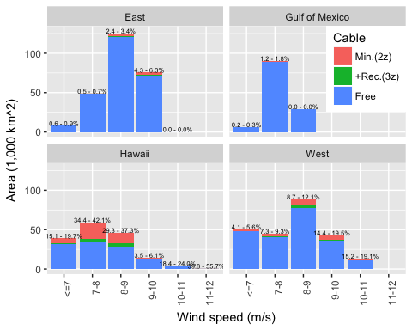

Figure 6 Wind speed (m/s) at 90m hub height and area per US territory with cable overlay (minimum - recommended %).

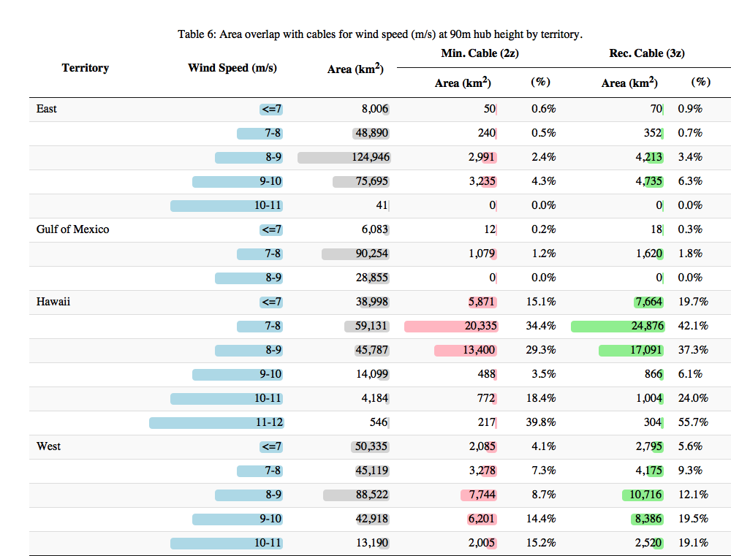

# Conclusions

Given climate change impacts of fossil fuel energy production (Pachauri et al. 2015), development of clean renewable energy alternatives are imperative for the sustainable future of the United States and rest of the planet. These energy sources however vary widely in geographic and temporal availability and may compete with other uses. The submarine cable industry provides critical power and telecommunication services, such that safe operation and maintenance must be heeded as marine renewable energy sources are developed (Communications Security, Reliability and Interoperability Council IV 2014, 2016). The submarine cable safety avoidance zones created and evaluated through this report are products intended to minimize conflict at the plannnig stage between these competing uses.

Although the US currently only has one marine renewable energy facility in full production at Block Island NJ, many more are in pilot and proposal phases with much future potential (Beiter et al. 2017; Lehmann et al. 2017; Uihlein and Magagna 2016). These spatial avoidance zones are advisory. Should there be overlapping interest, negotiations between renewable energy developers and cable operators should be sought.

* diversify energy portfolio. Solar cheapest, but b/c duck curve. Costs coming down, especially for floating offshore wind (recent report).

# (APPENDIX) Appendix

# Detailed Maps by US Territory of Cable Buffer and Renewable Energy

### Alaska

See Figure 7.

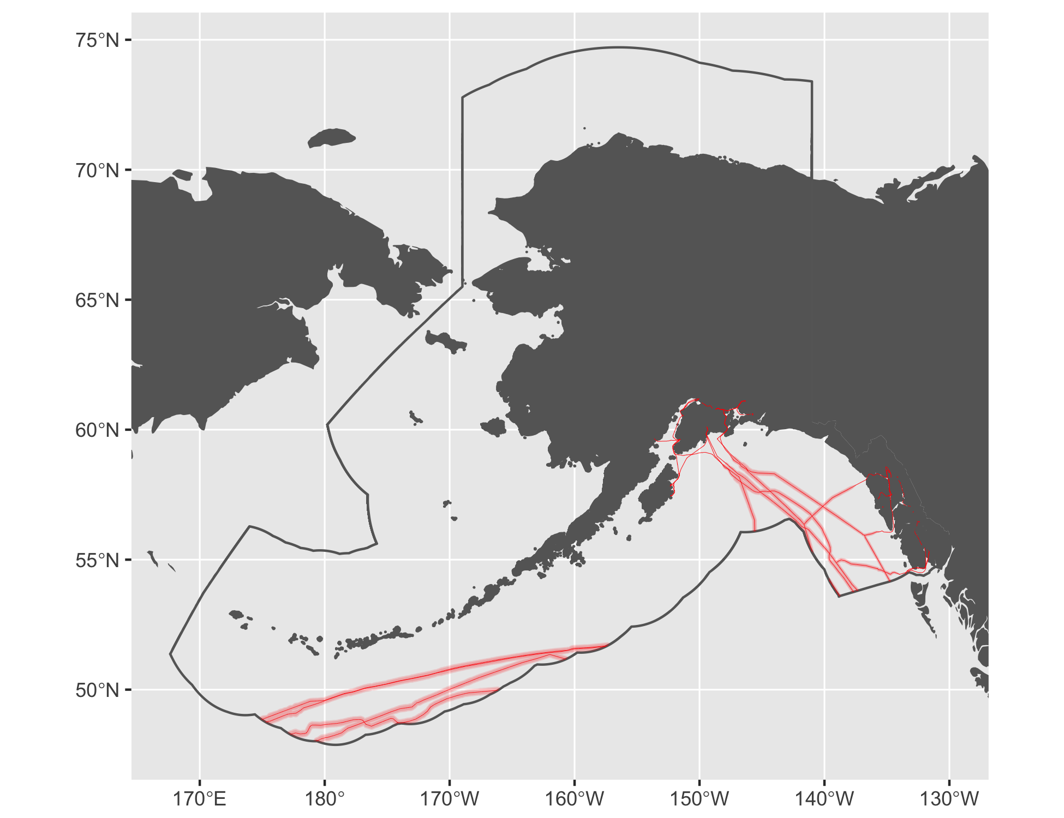

Figure 7 Cable buffers for Alaska.

#### Tidal

See Figure 8.

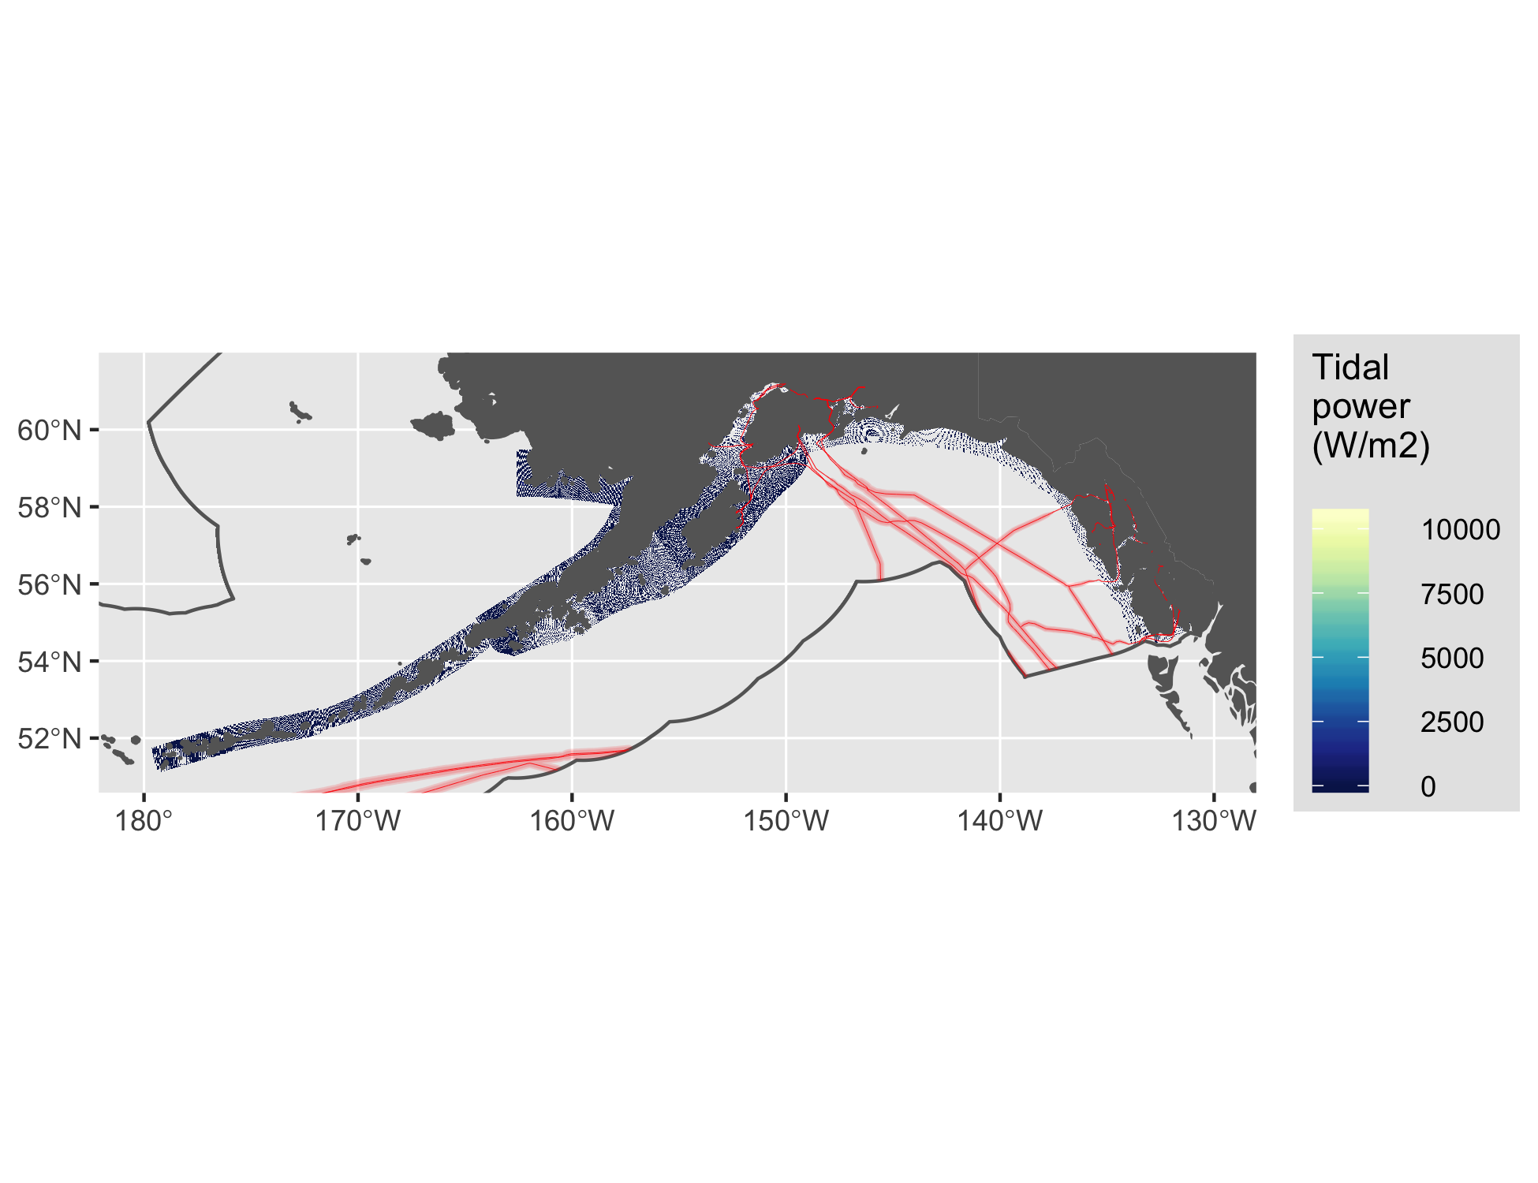

Figure 8 Tidal energy for Alaska.

#### Wave

See Figure 9.

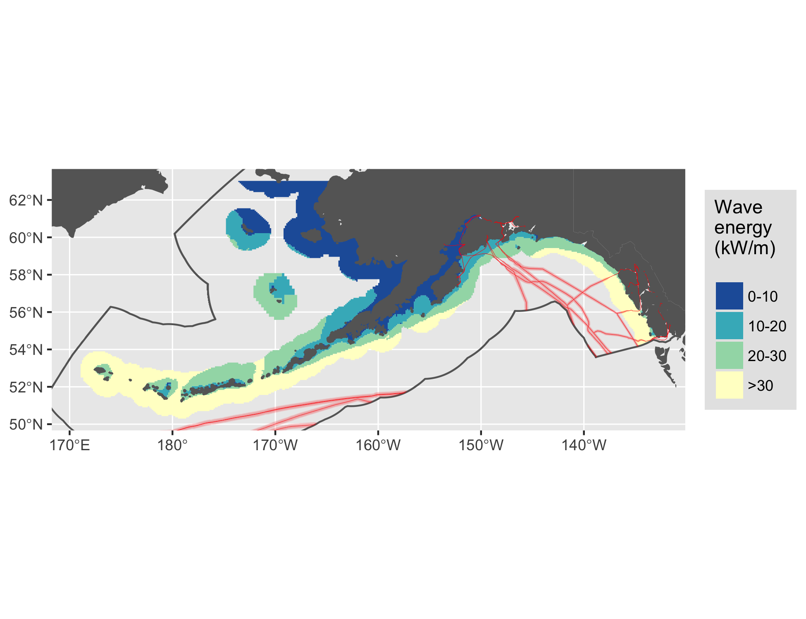

Figure 9 Wave energy for Alaska.

### East

See Figure 10.

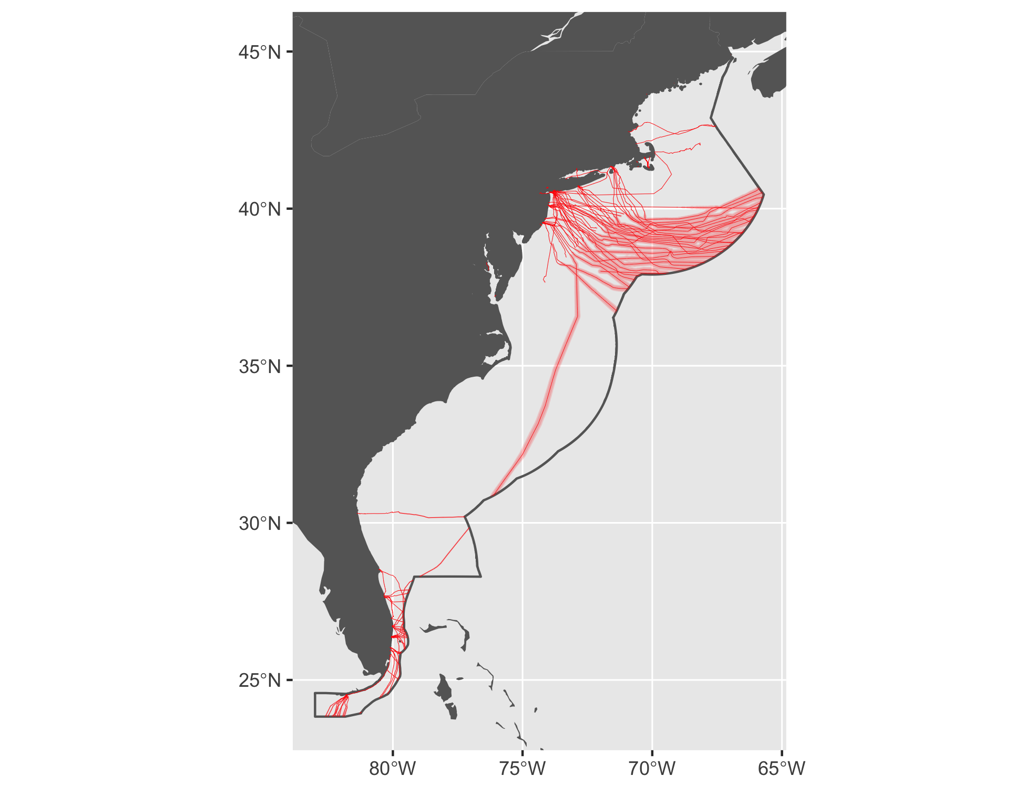

Figure 10 Cable buffers for East Coast.

#### Tidal

See Figure 11.

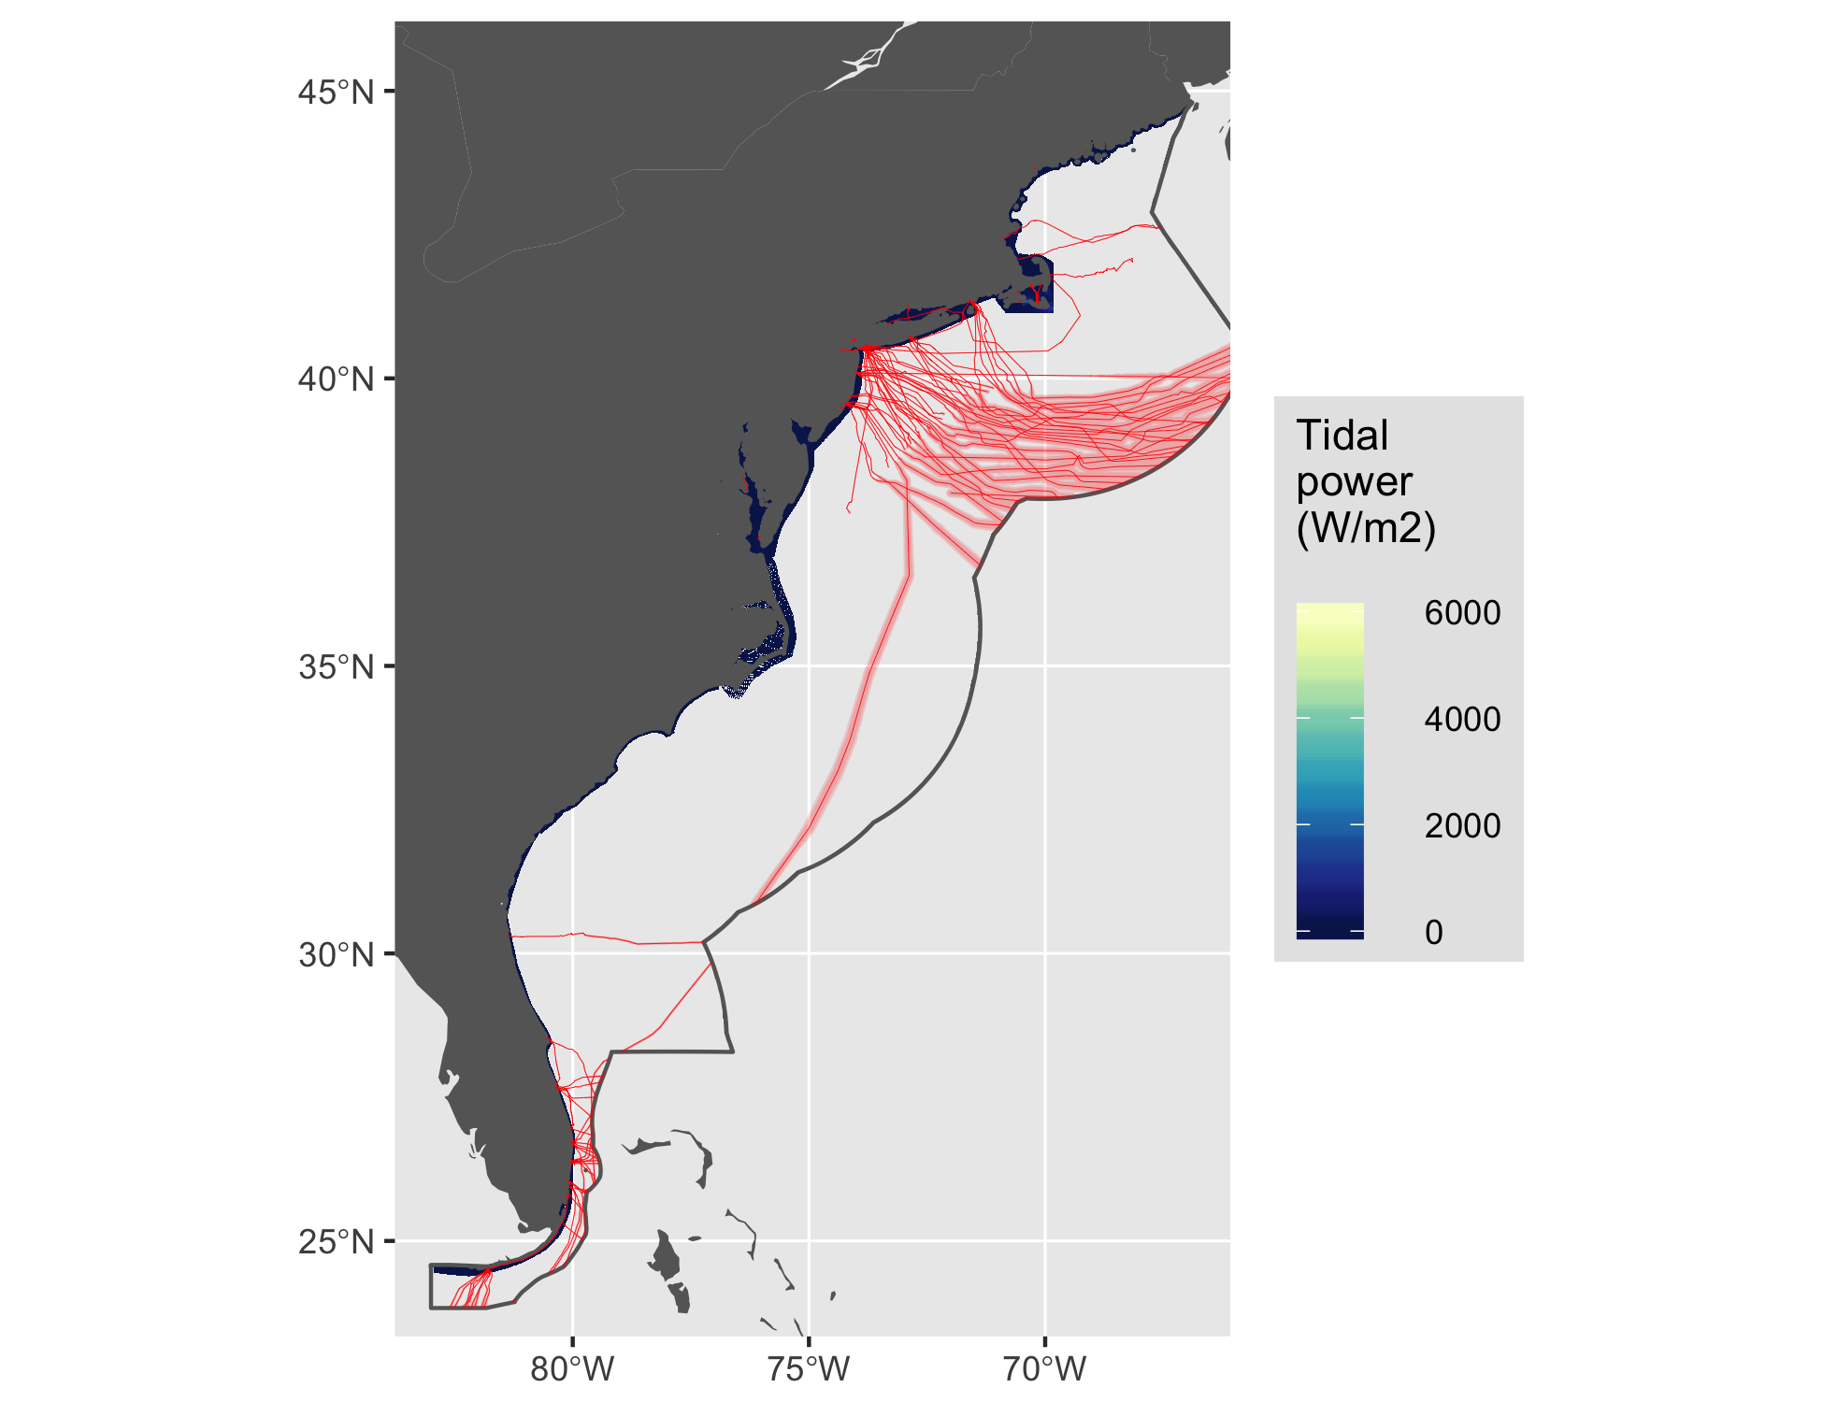

Figure 11 Tidal energy for East.

#### Wave

See Figure 12.

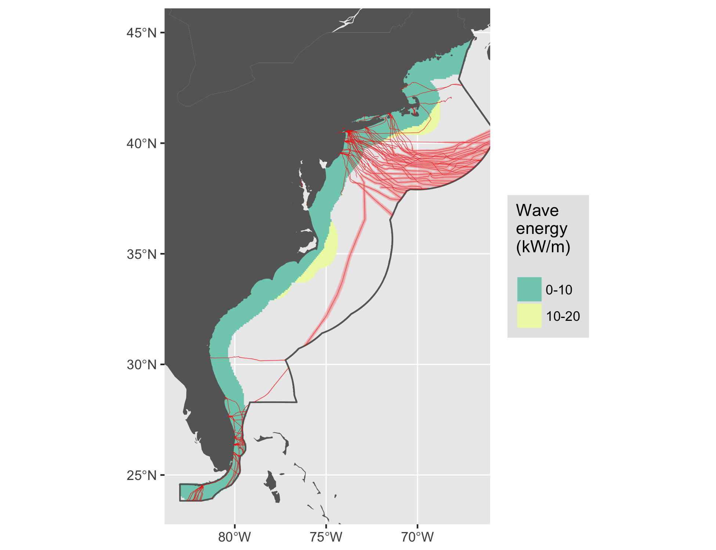

Figure 12 Wave energy for East.

#### Wind

See Figure 13.

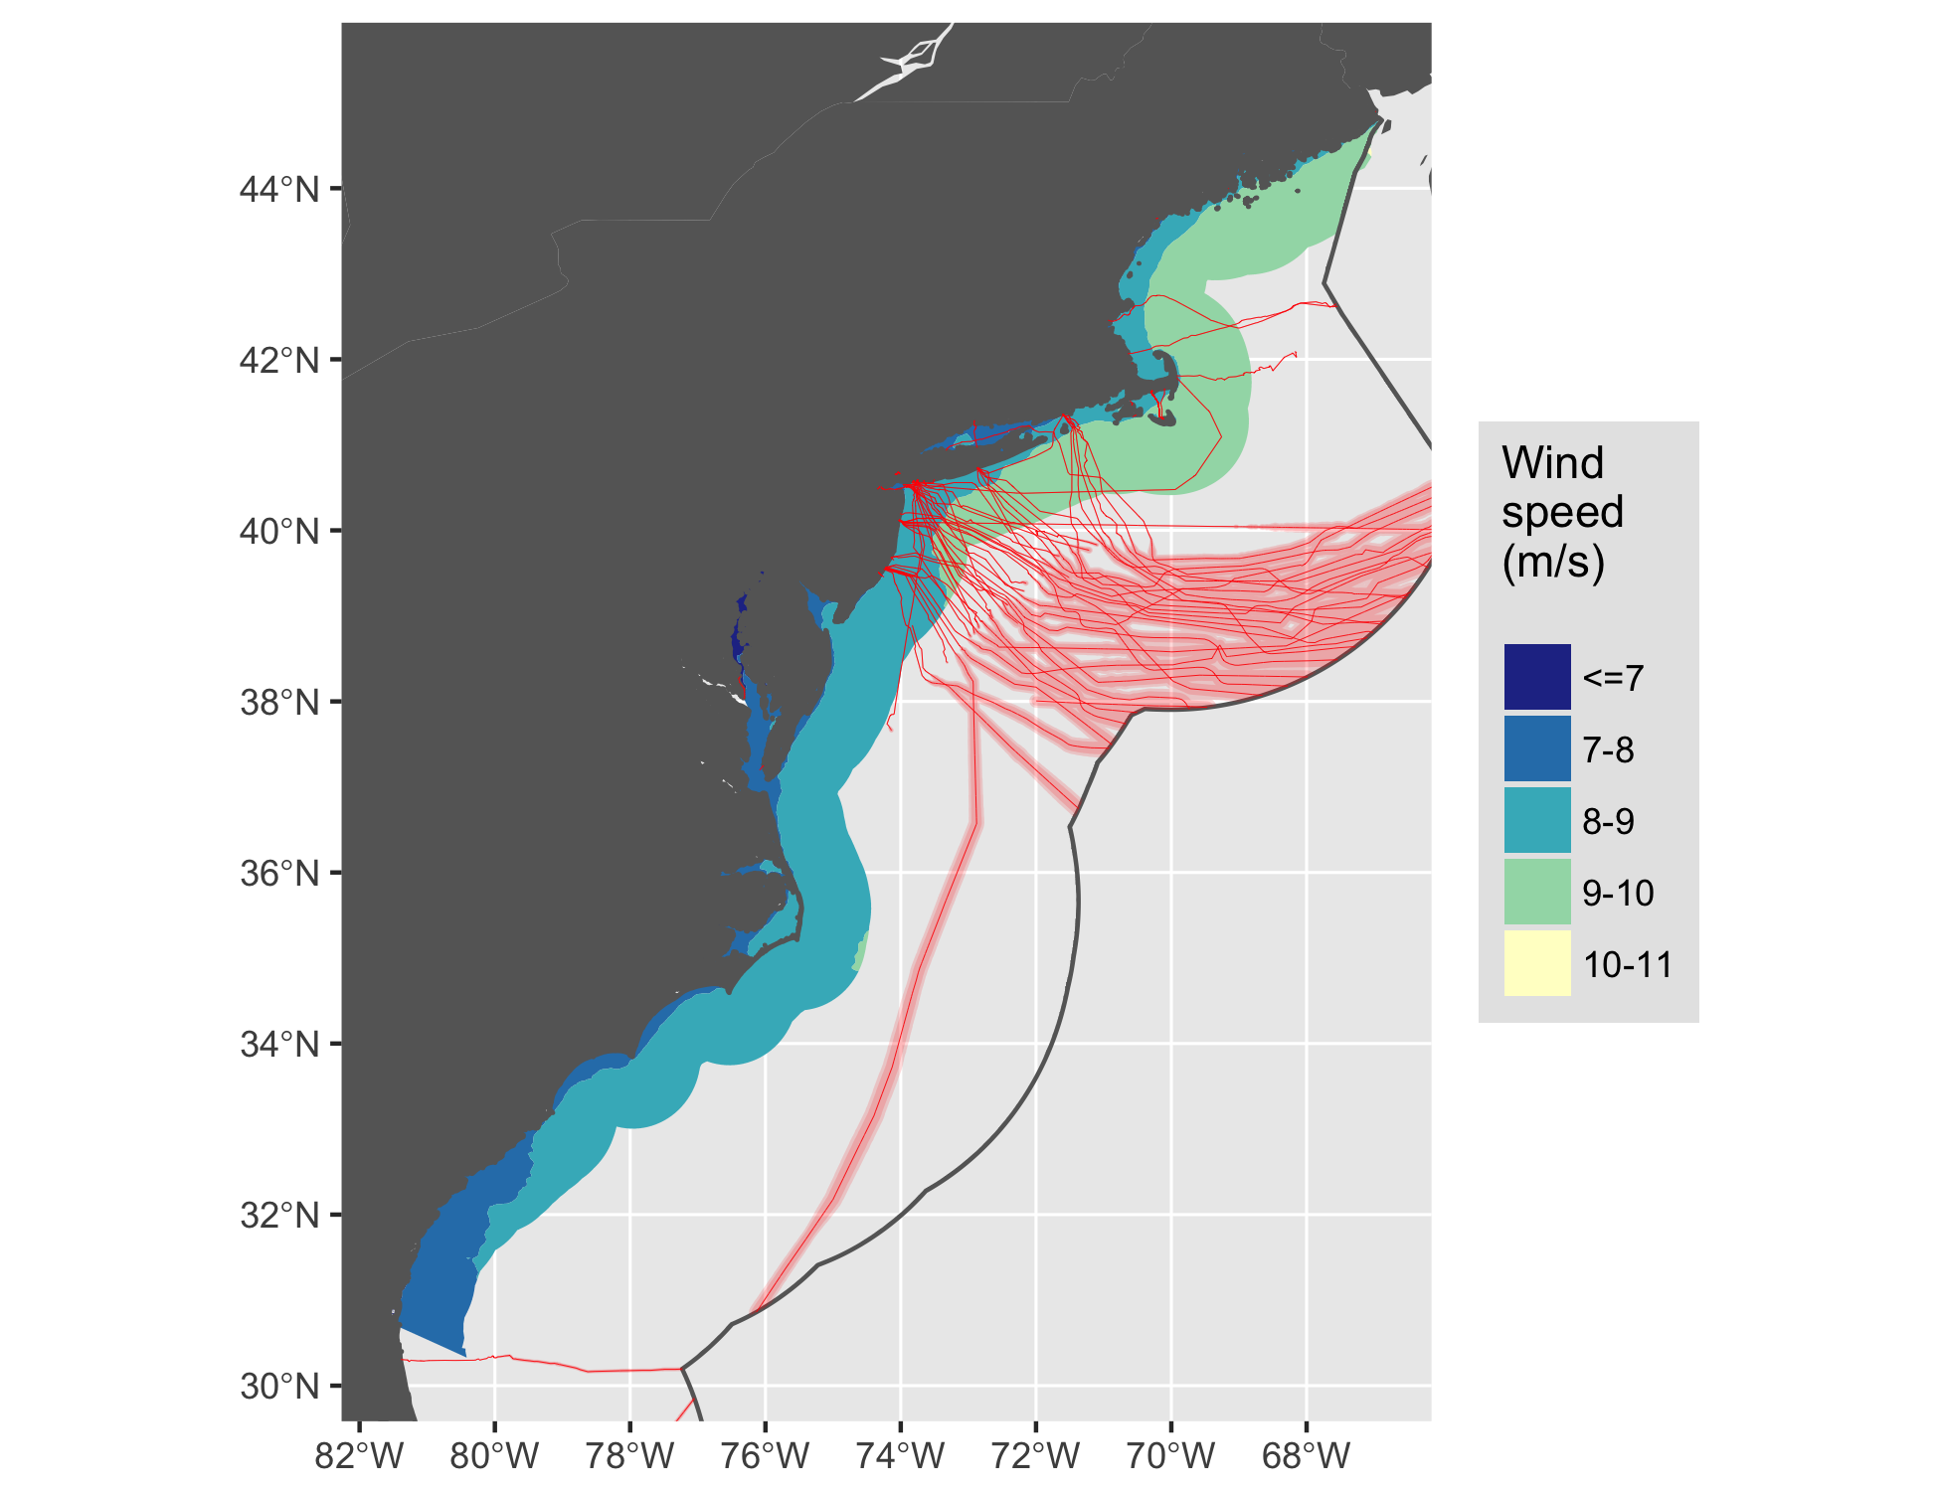

Figure 13 Wind energy for East.

### Guam

See Figure 14.

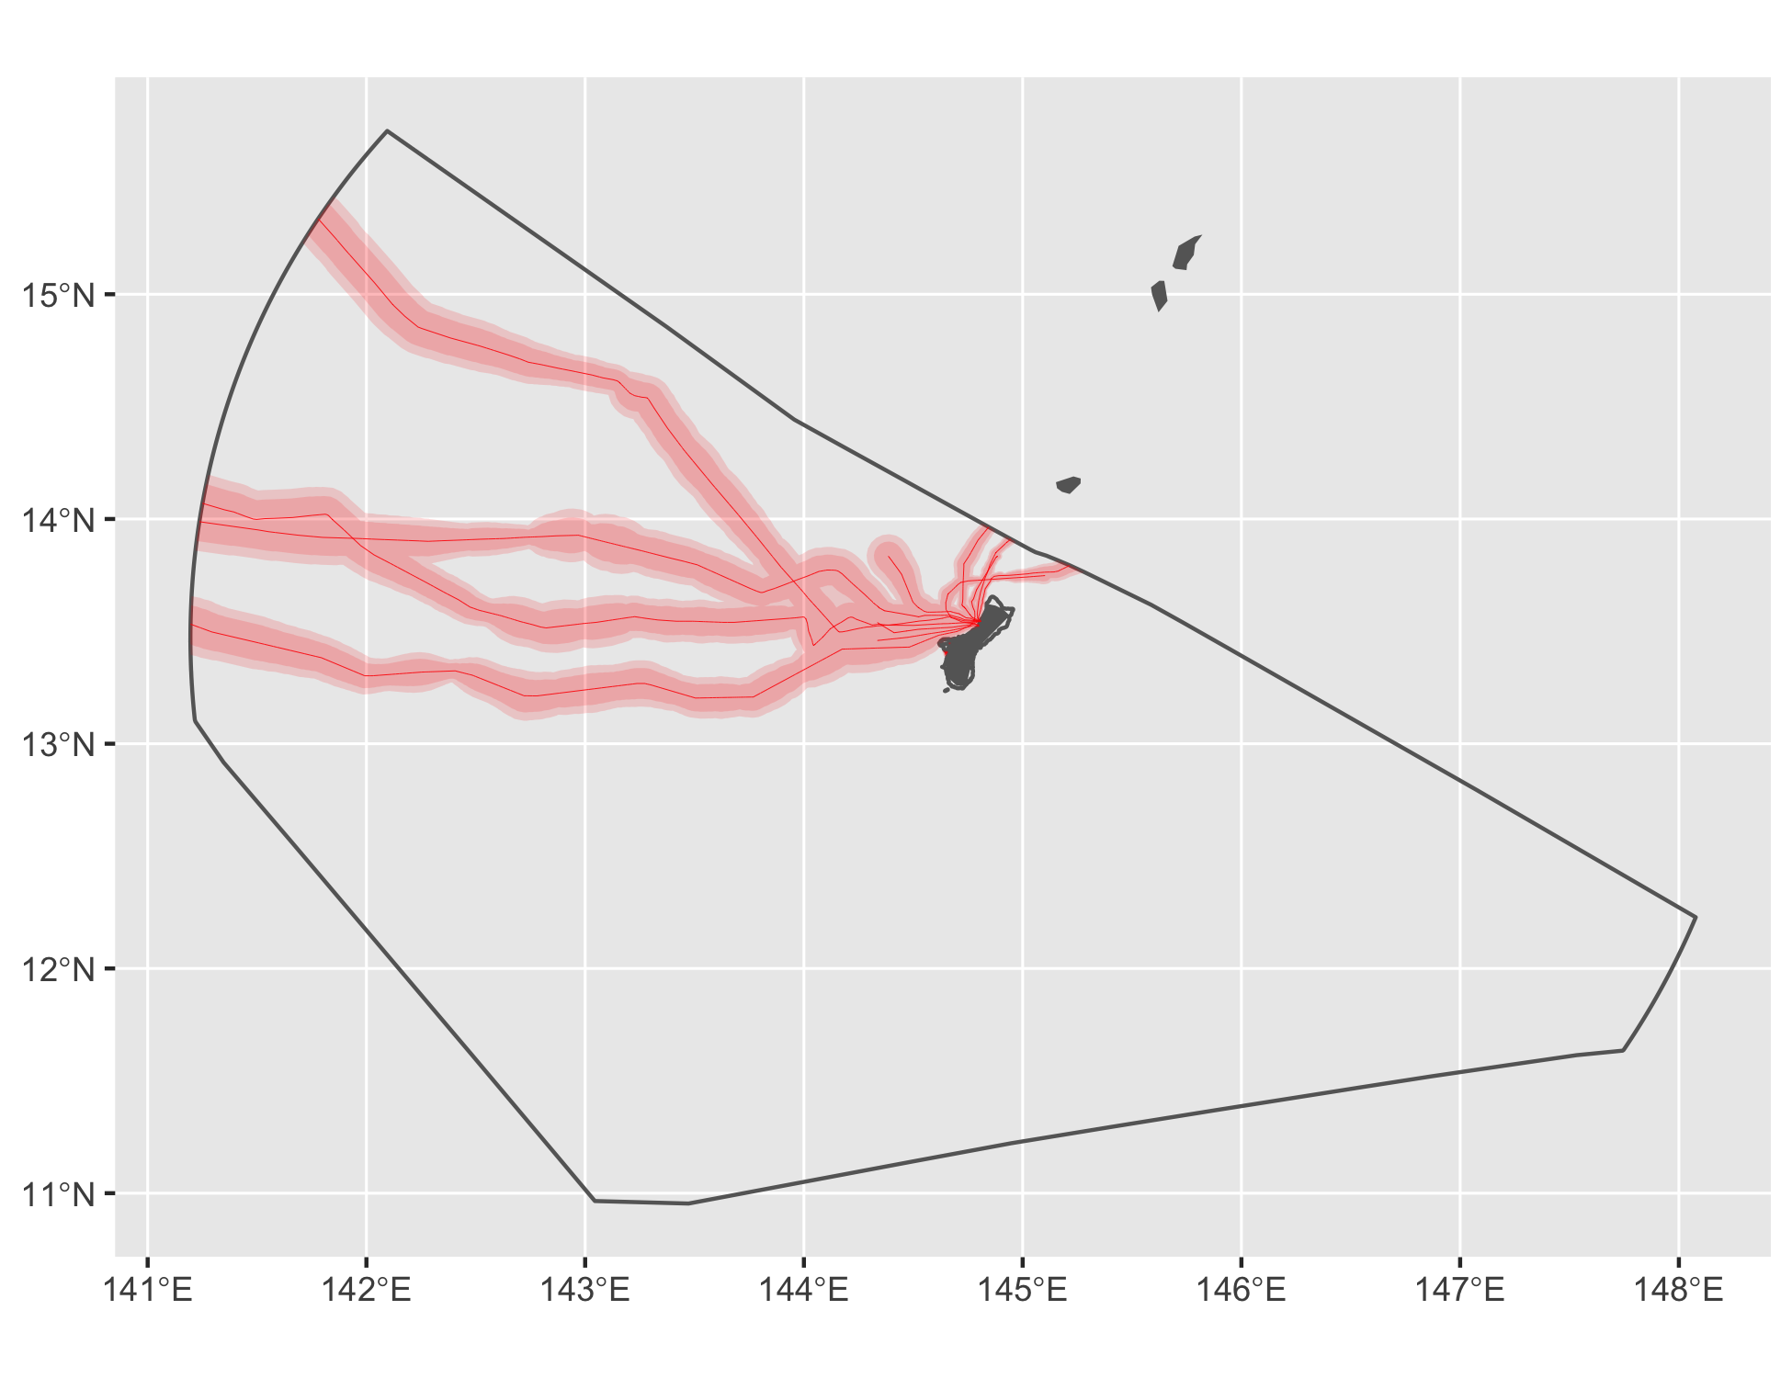

Figure 14 Cable buffers for Guam.

### Gulf of Mexico

See Figure 15.

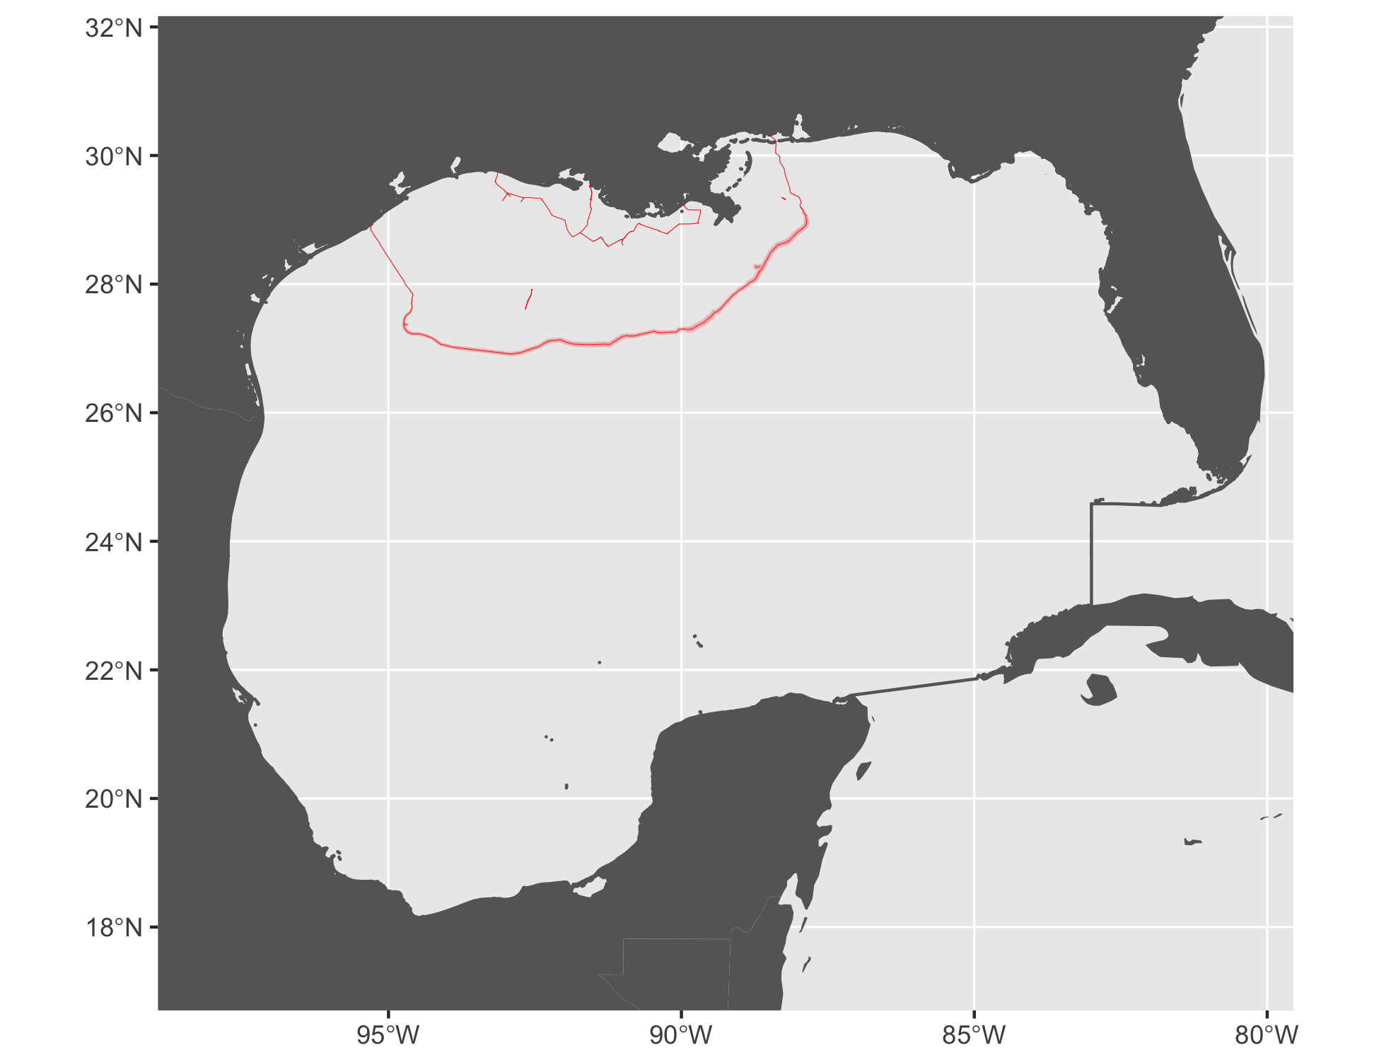

Figure 15 Cable buffers for Gulf of Mexico.

#### Tidal

See Figure 16.

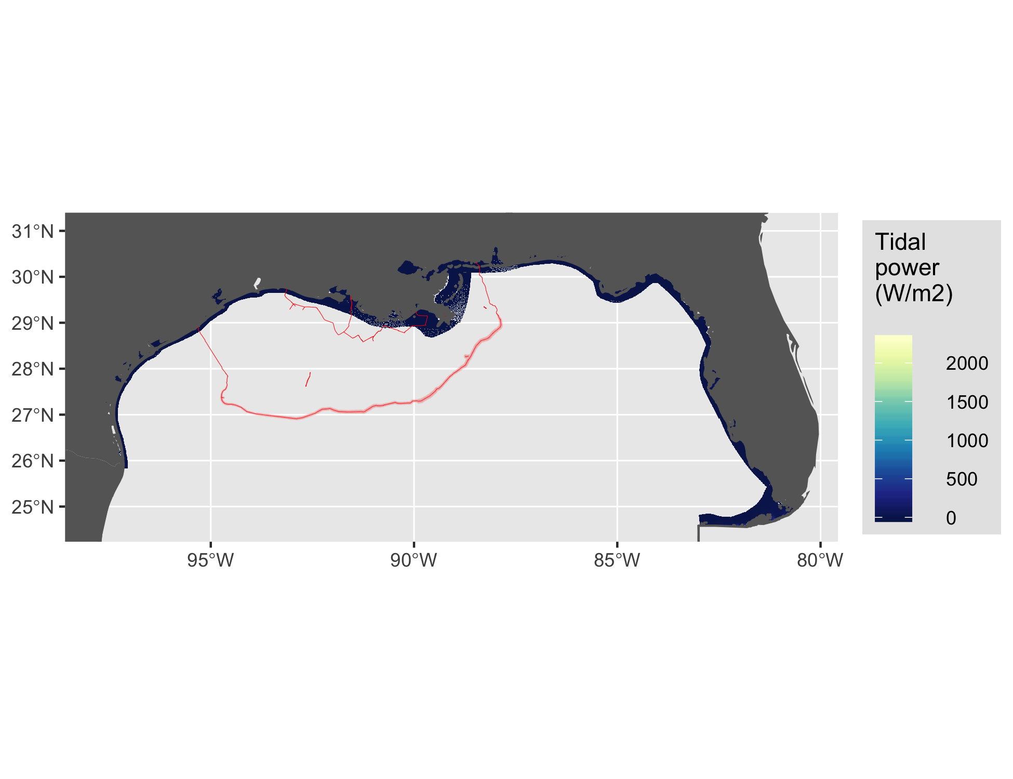

Figure 16 Tidal energy for Gulf of Mexico.

#### Wave

See Figure 17.

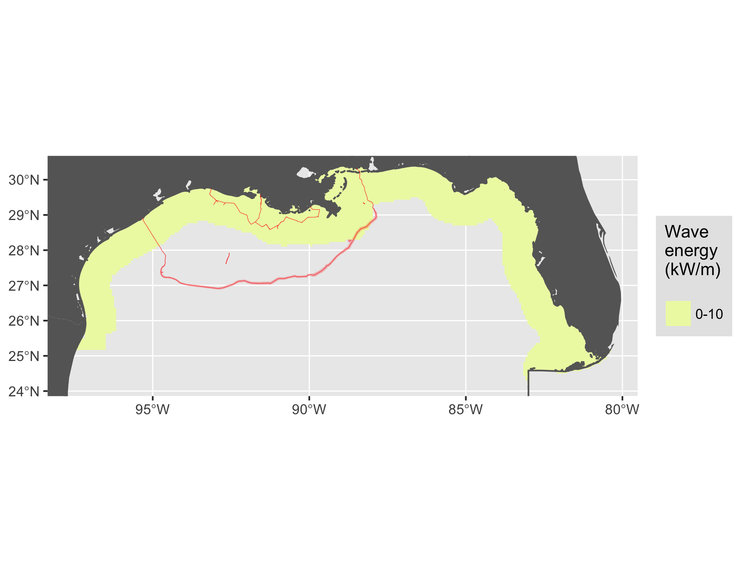

Figure 17 Wave energy for Gulf of Mexico.

#### Wind

See Figure 18.

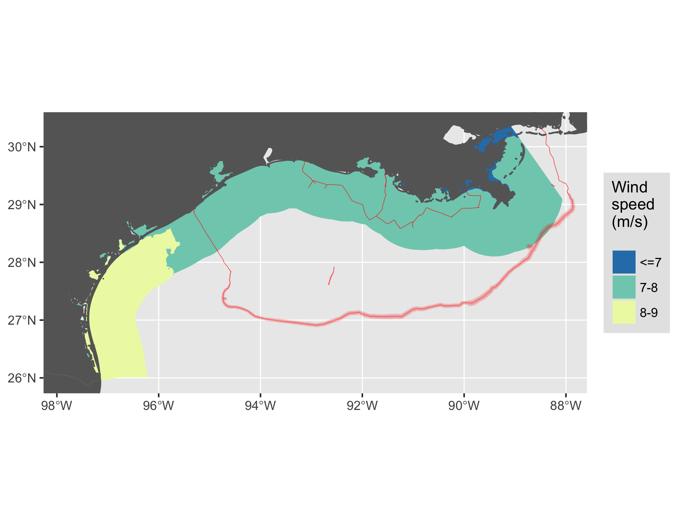

Figure 18 Wind energy for Gulf of Mexico.

### Hawaii

See Figure 19.

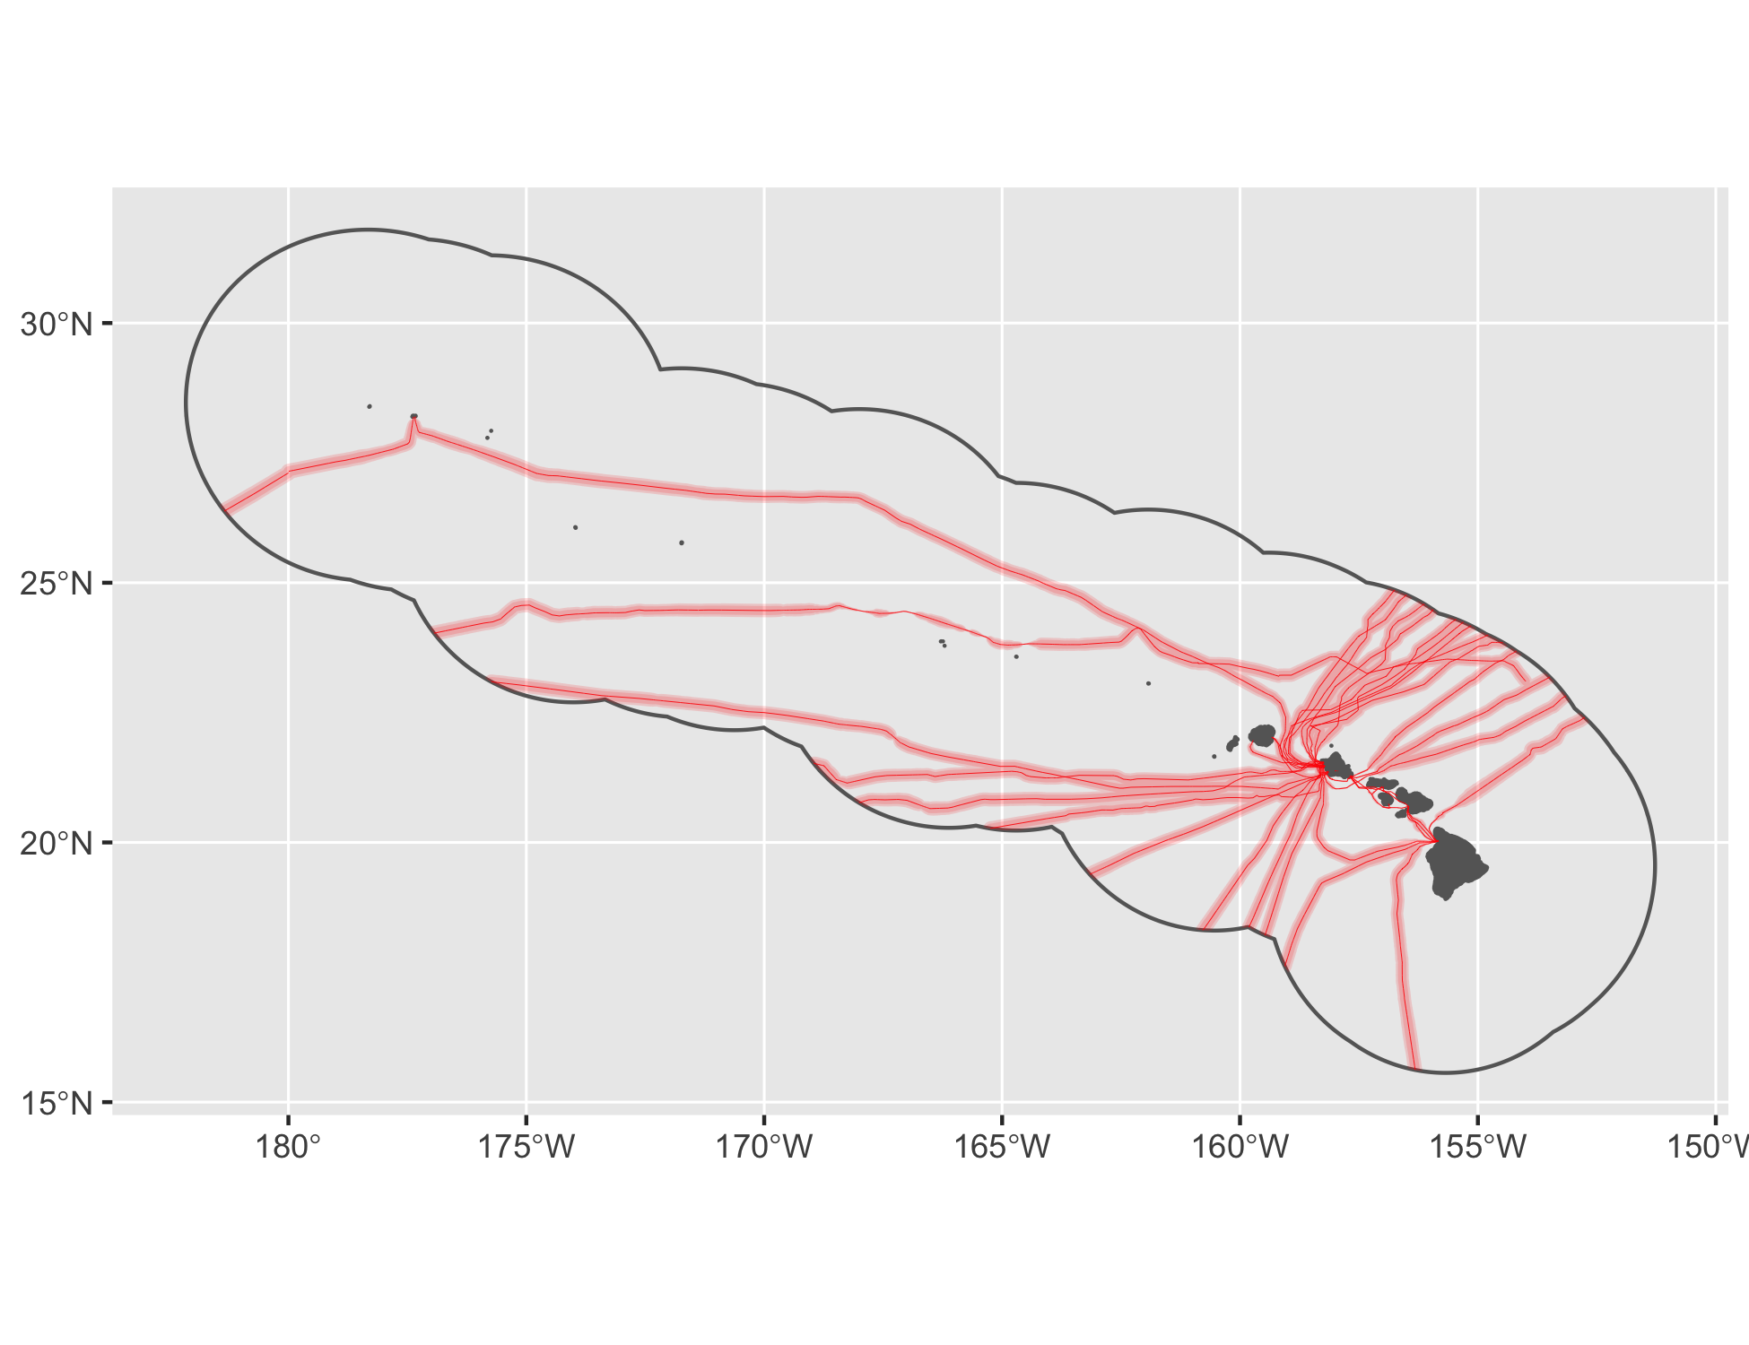

Figure 19 Cable buffers for Hawaii.

#### Wave

See Figure 20.

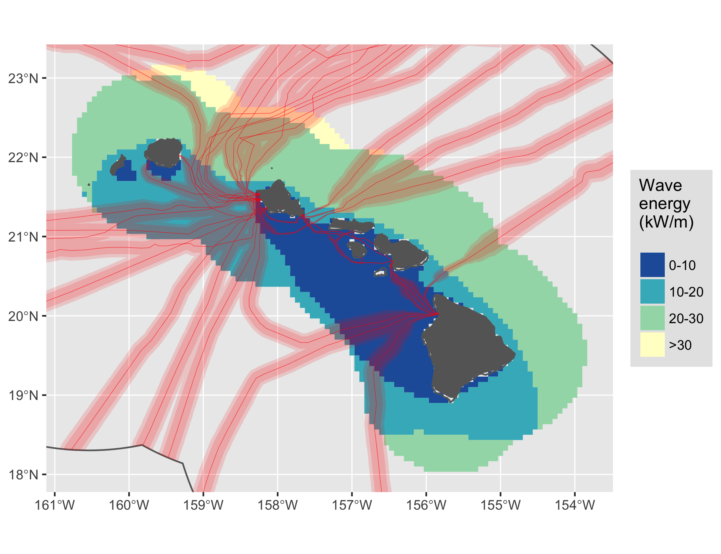

Figure 20 Wave energy for Hawaii.

#### Wind

See Figure 21.

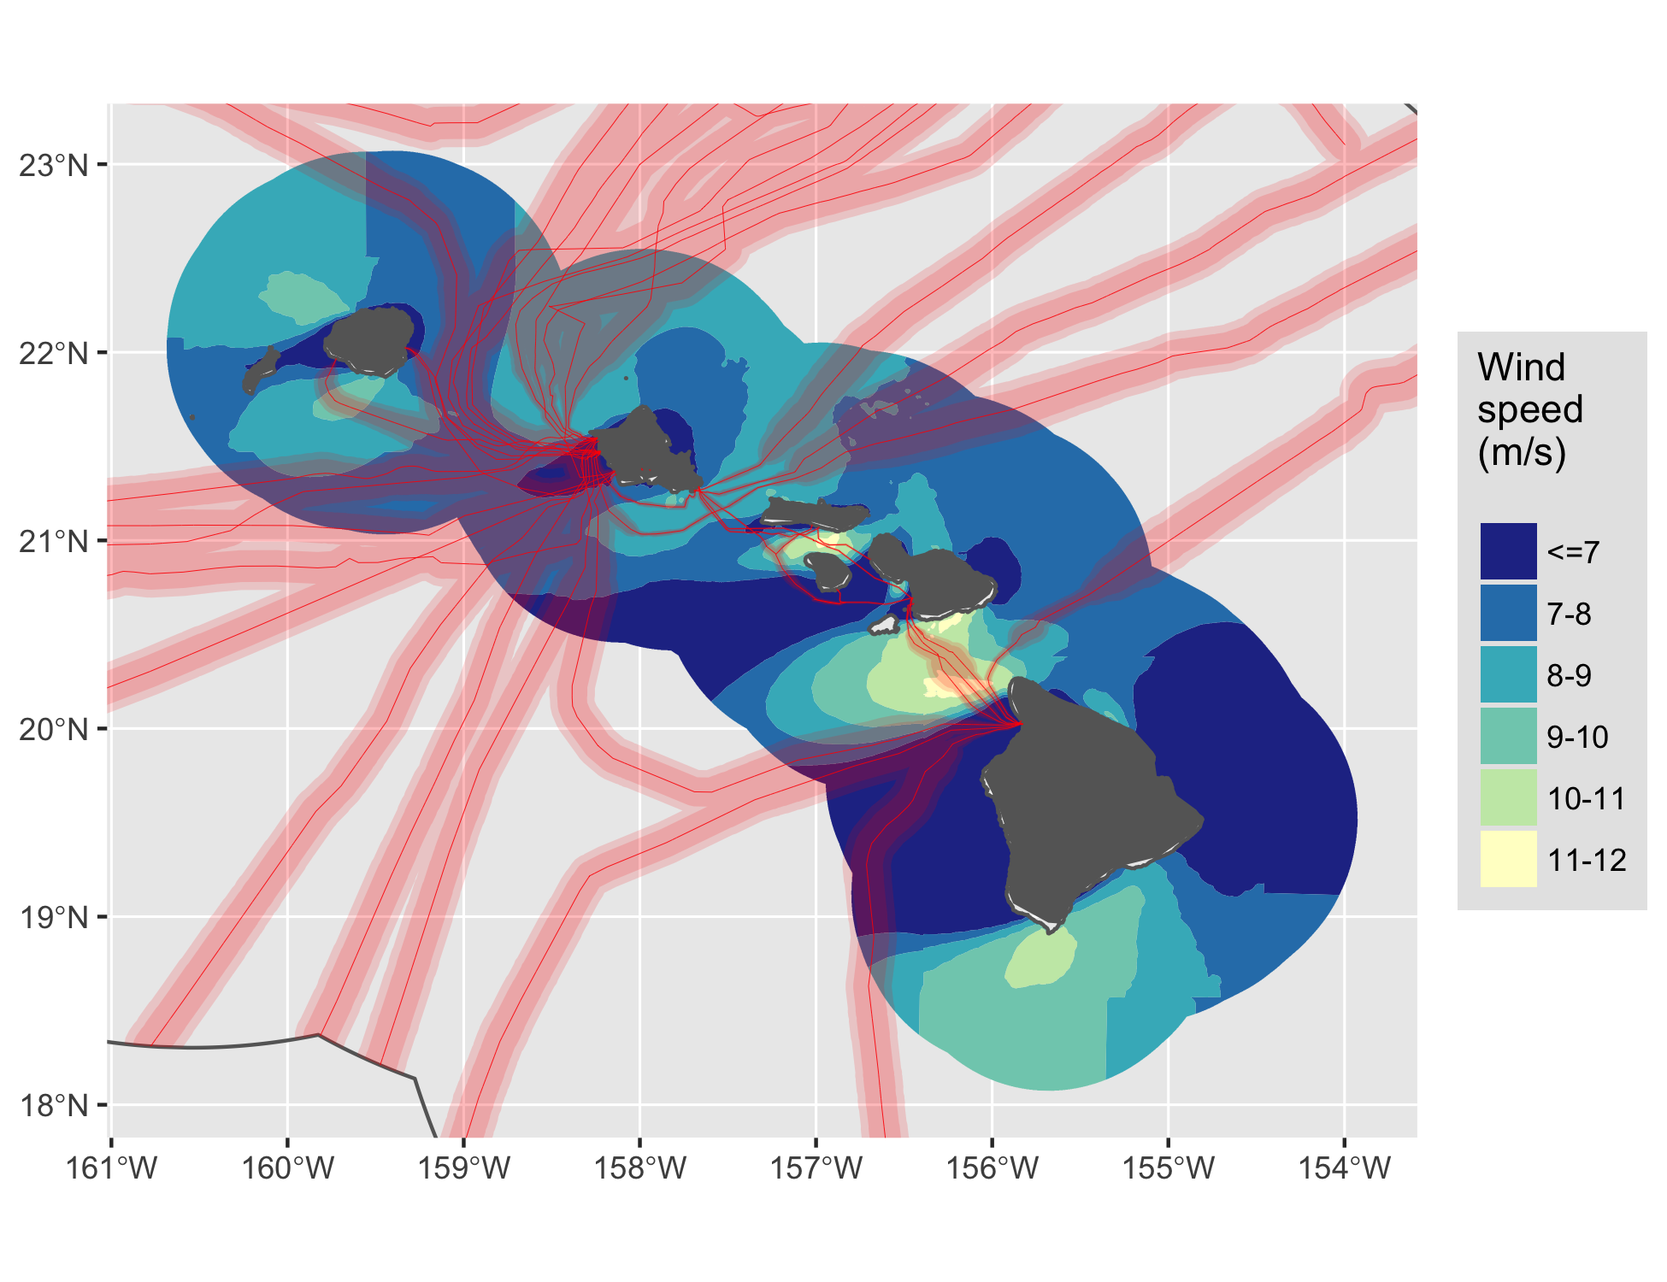

Figure 21 Wind energy for Hawaii.

### Johnston Atoll

See Figure 22.

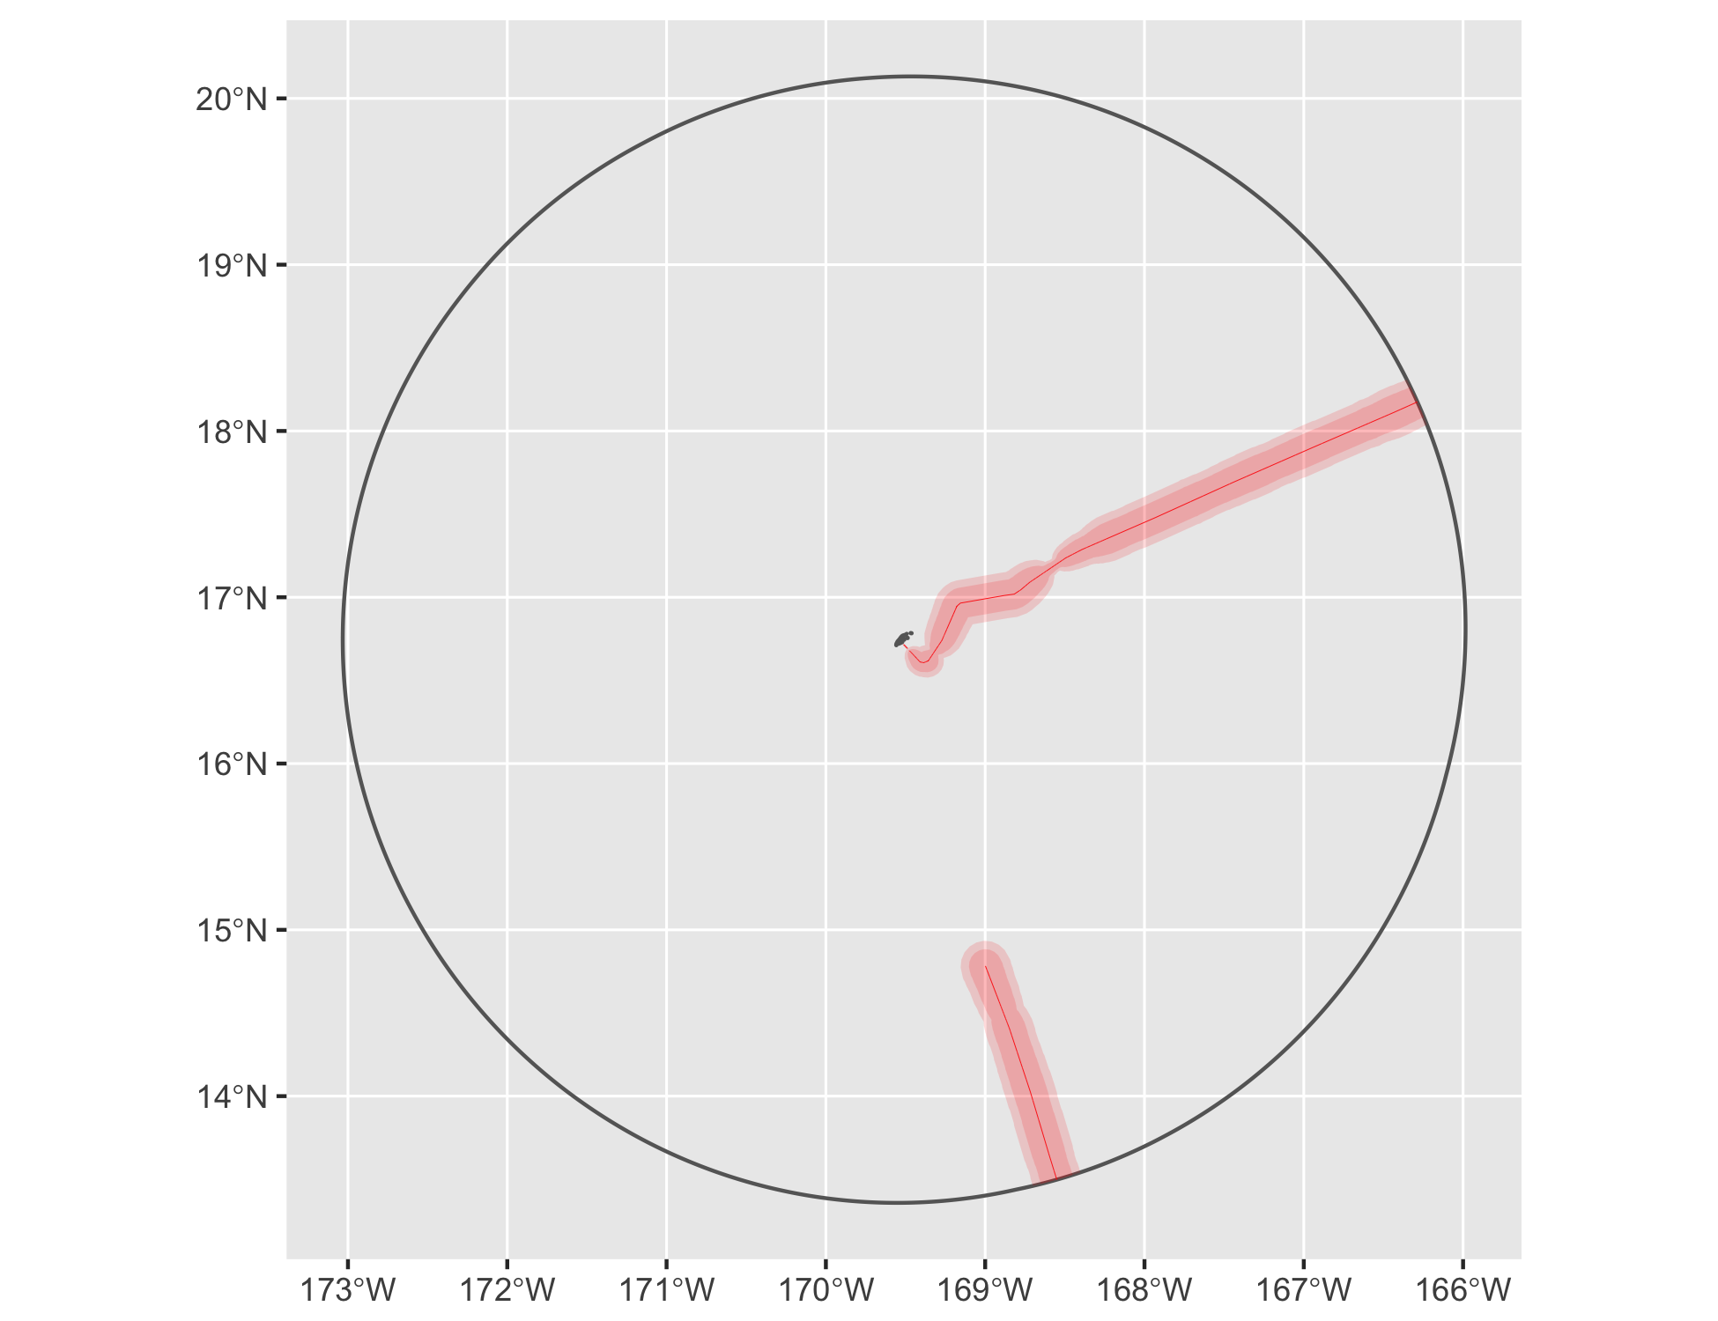

Figure 22 Cable buffers for Johnston Atoll.

### N Mariana Islands

See Figure 23.

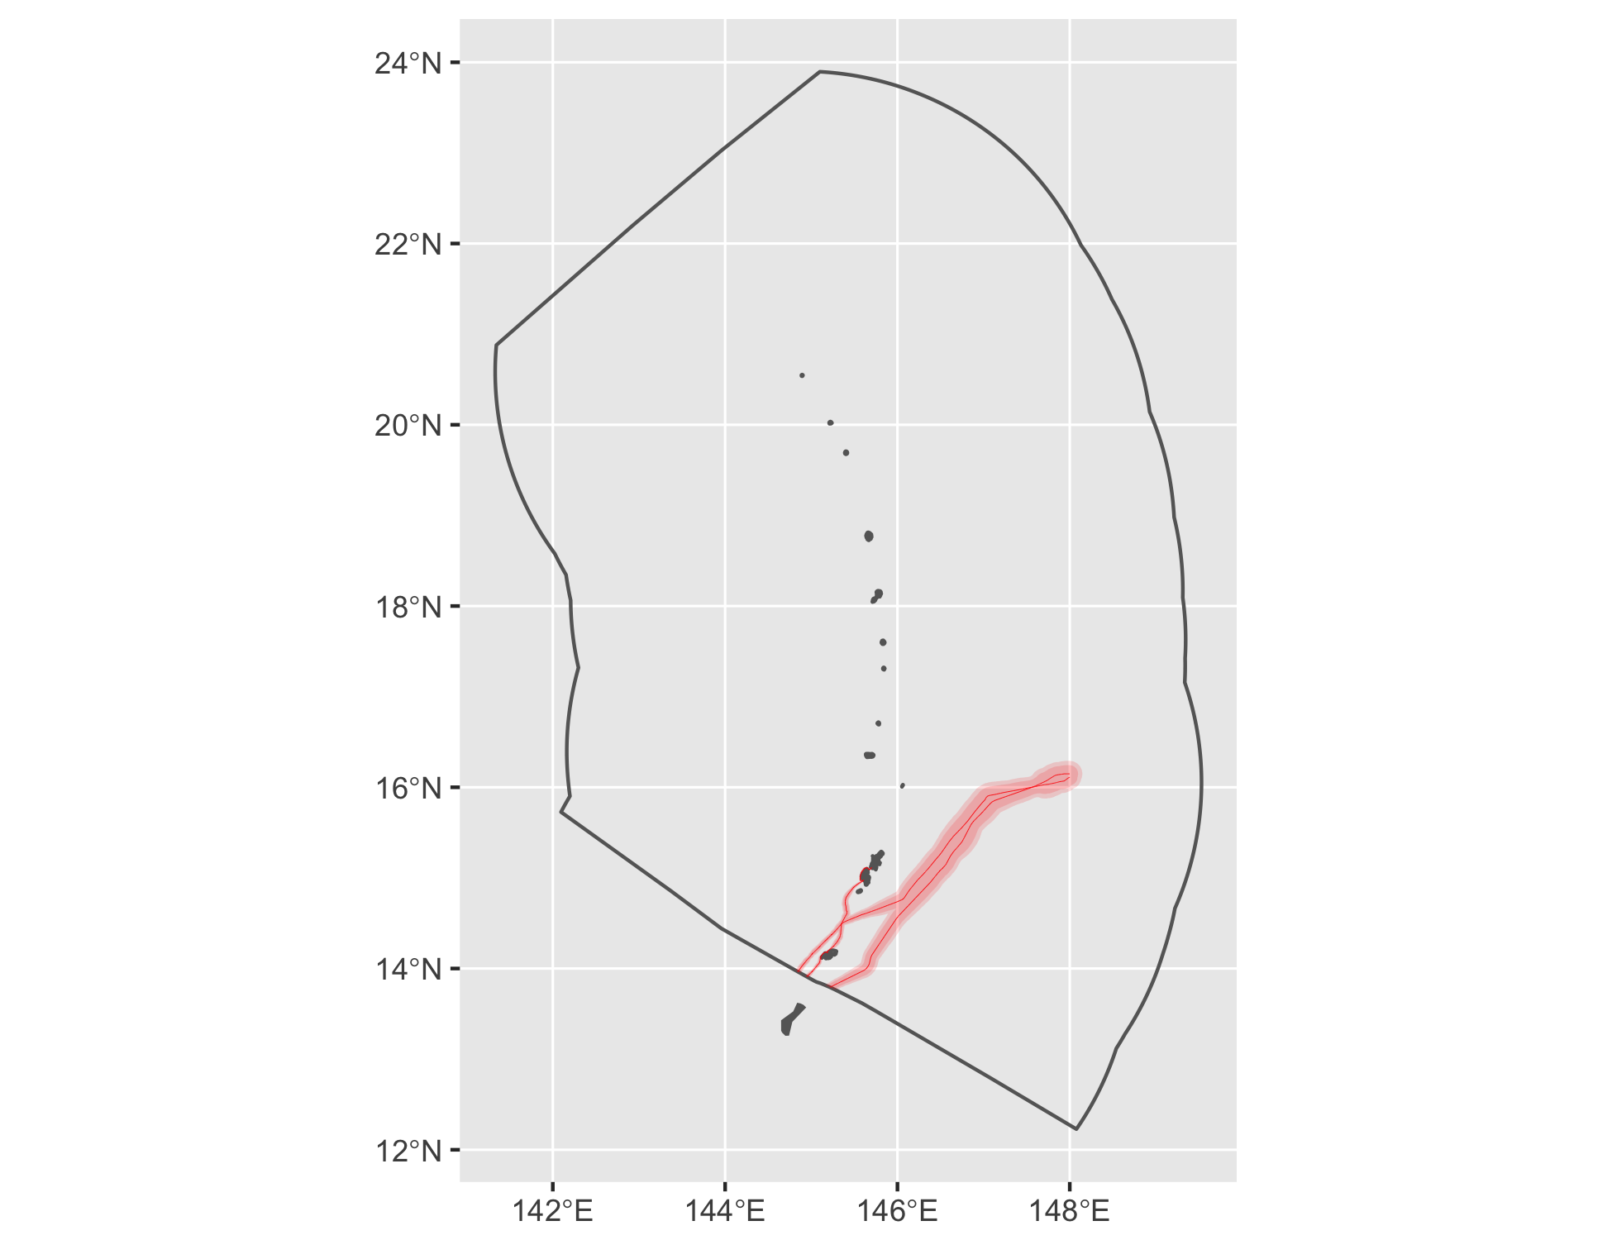

Figure 23 Cable buffers for N Mariana Islands.

### Palmyra Atoll

See Figure 24.

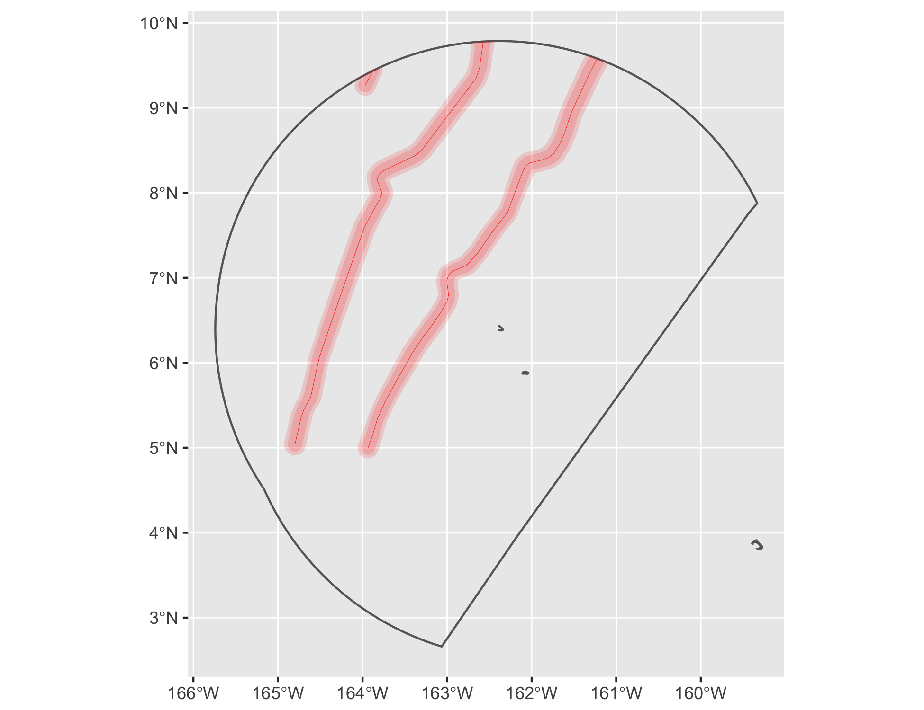

Figure 24 Cable buffers for Palmyra Atoll.

### Puerto Rico

See Figure 25.

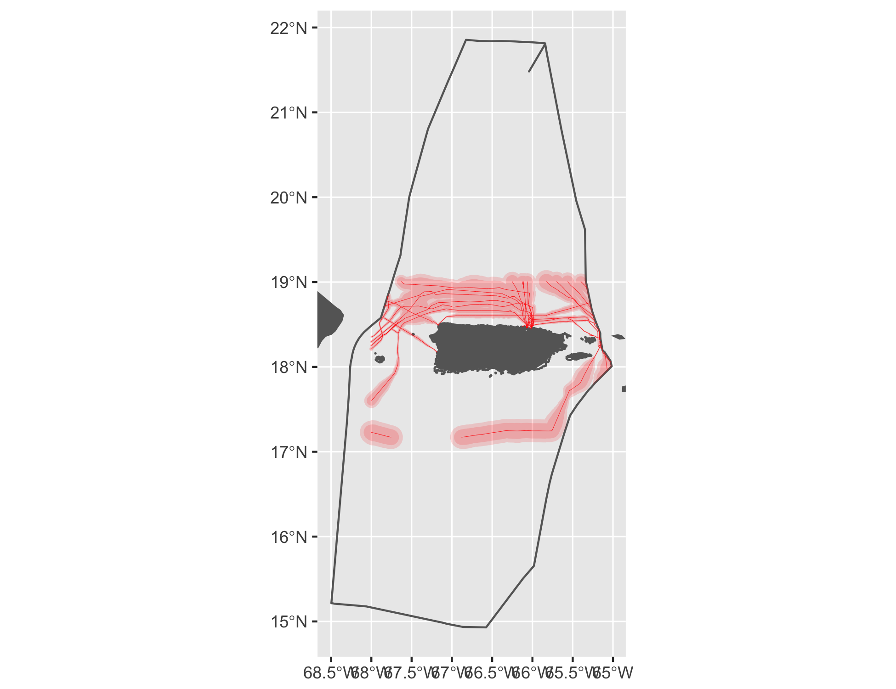

Figure 25 Cable buffers for Puerto Rico.

#### Tidal

See Figure 26.

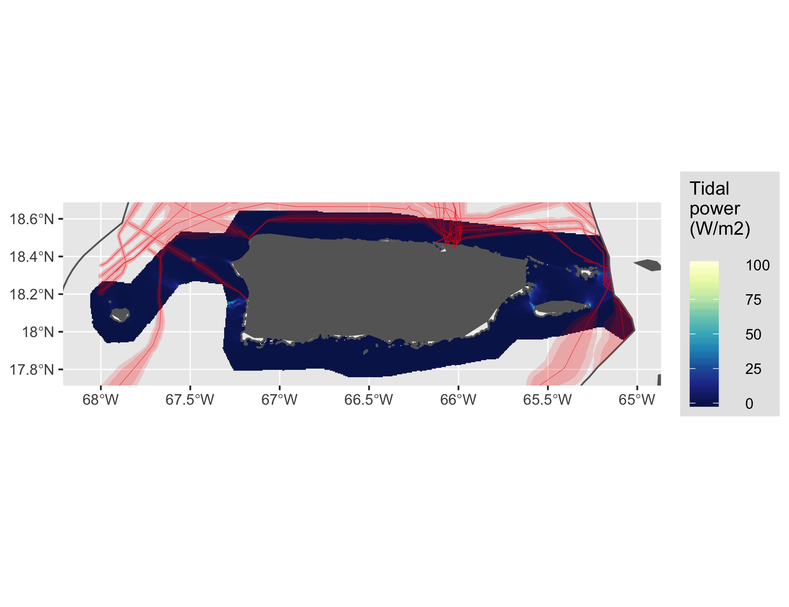

Figure 26 Tidal energy for Puerto Rico.

#### Wave

See Figure 27.

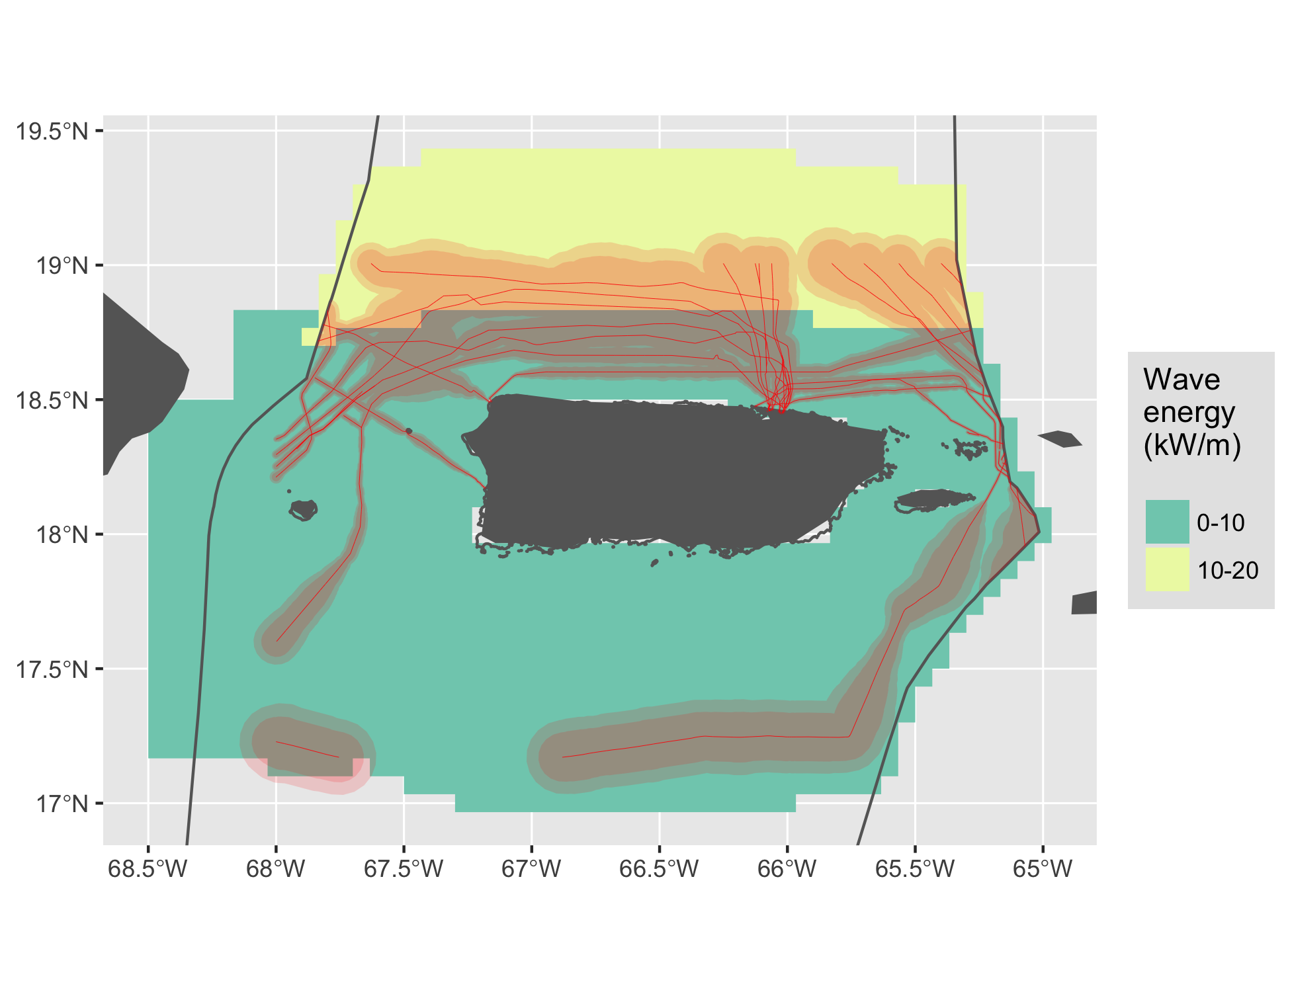

Figure 27 Wave energy for Puerto Rico.

### US Virgin Islands

See Figure 28.

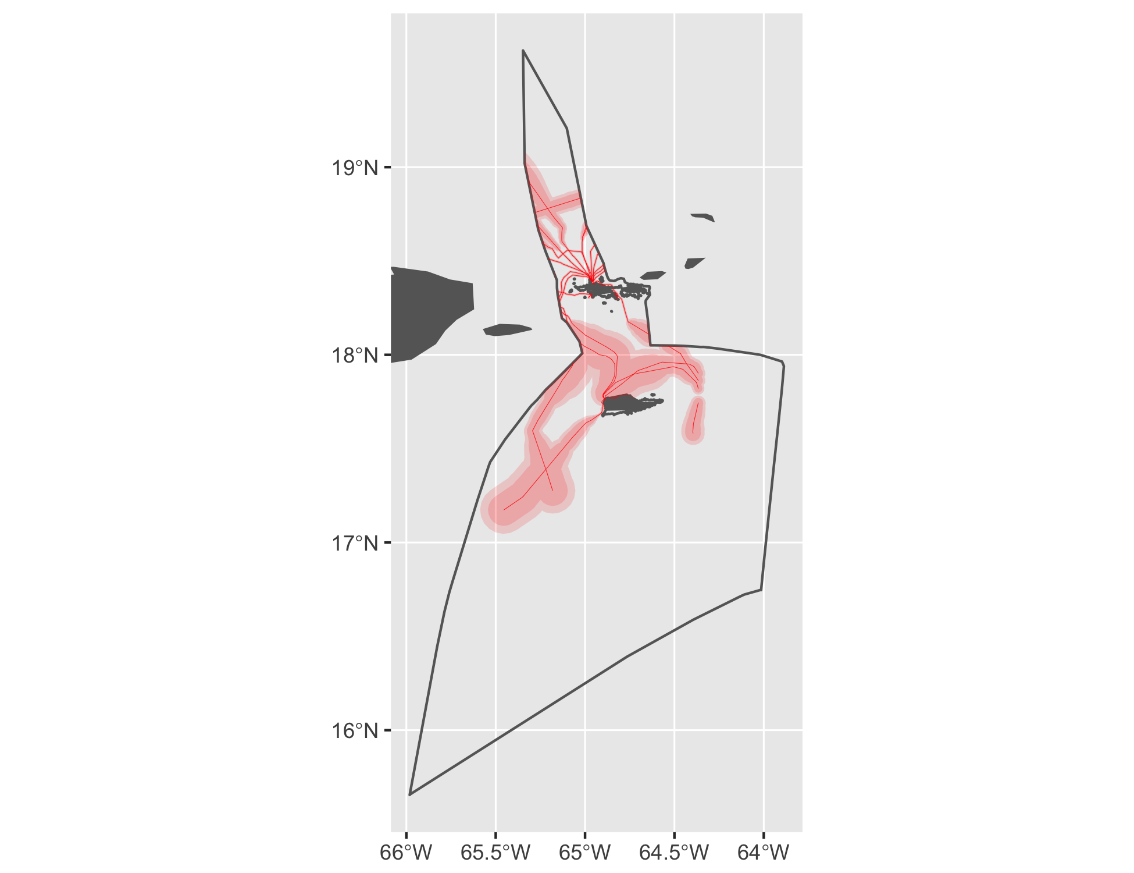

Figure 28 Cable buffers for US Virgin Islands.

#### Tidal

See Figure 29.

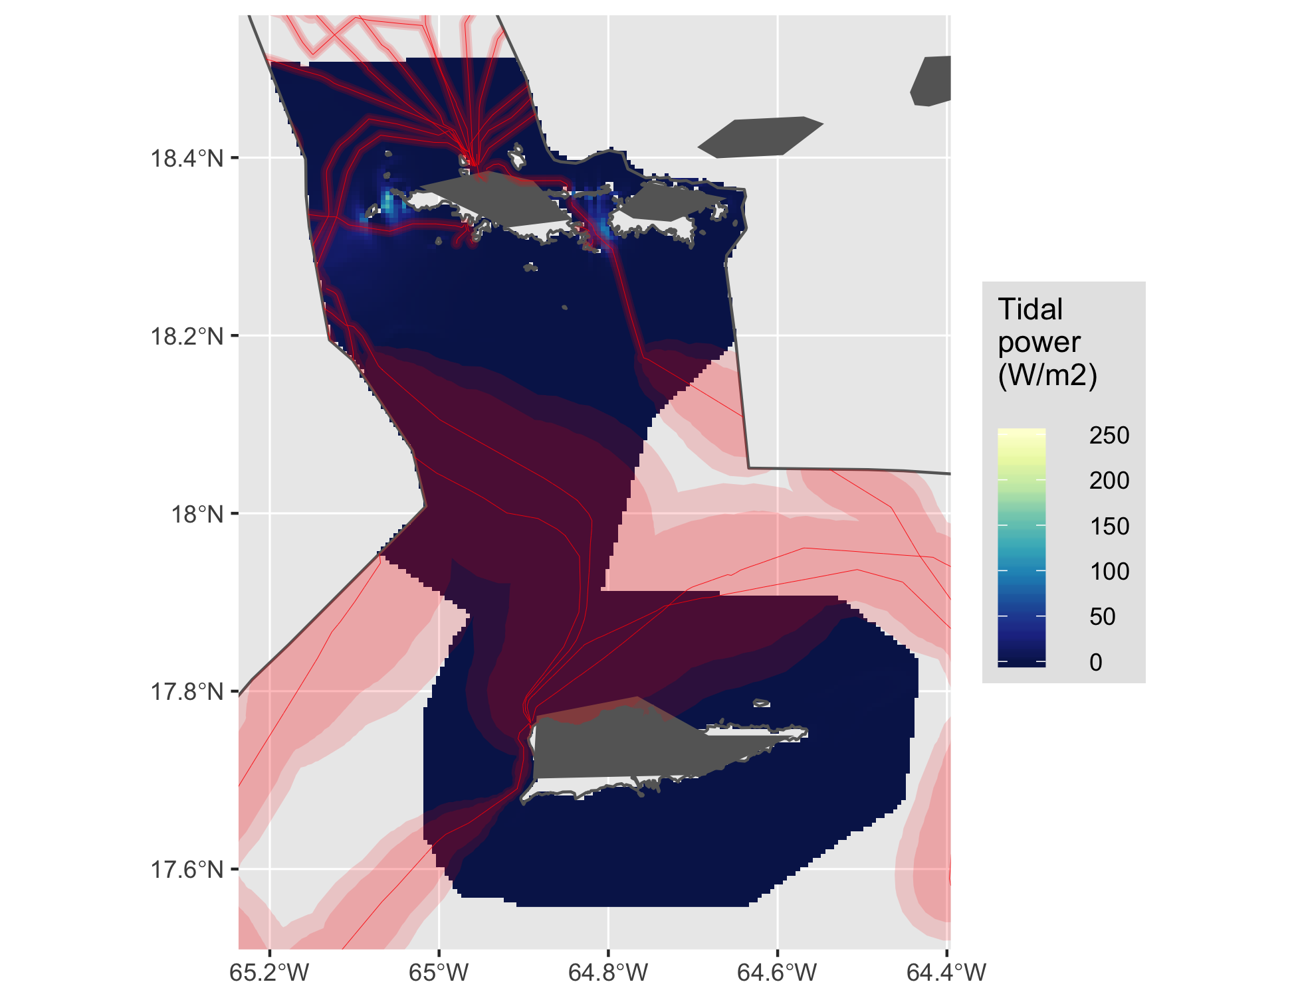

Figure 29 Tidal energy for US Virgin Islands.

#### Wave

See Figure 30.

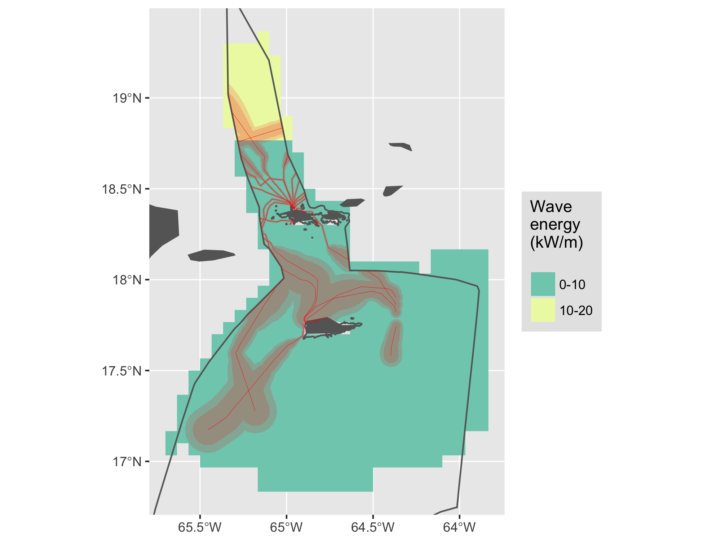

Figure 30 Wave energy for US Virgin Islands.

### Wake Island

See Figure 31.

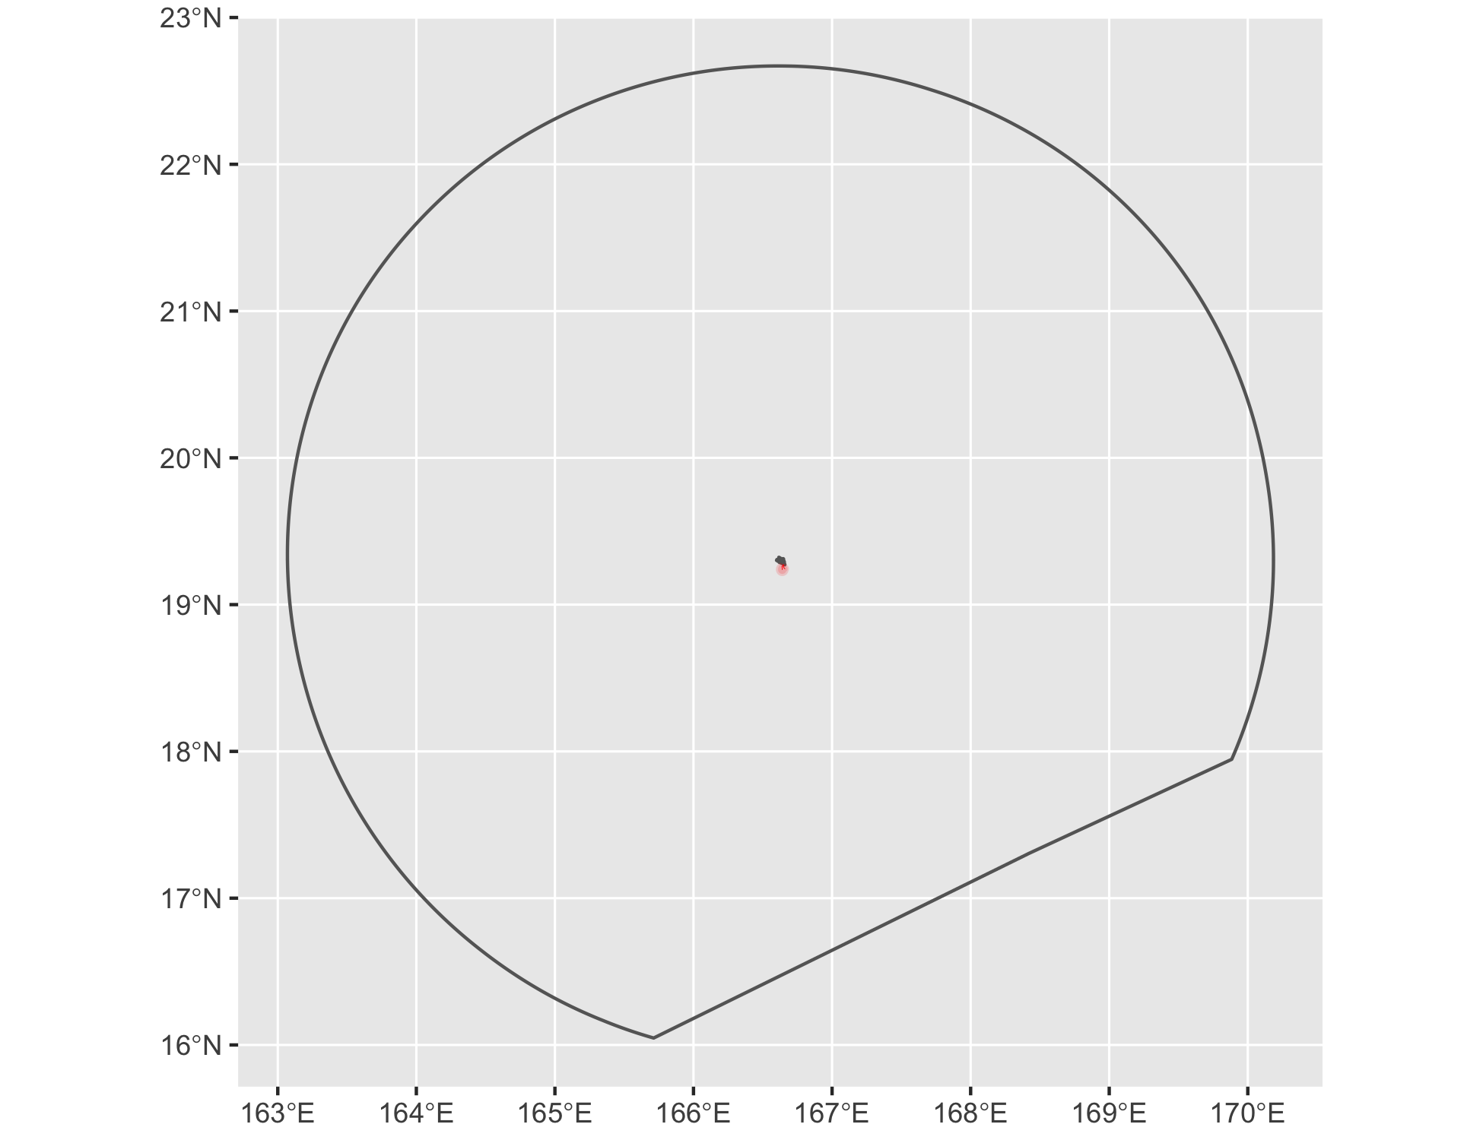

Figure 31 Cable buffers for Wake Island.

### West

See Figure 32.

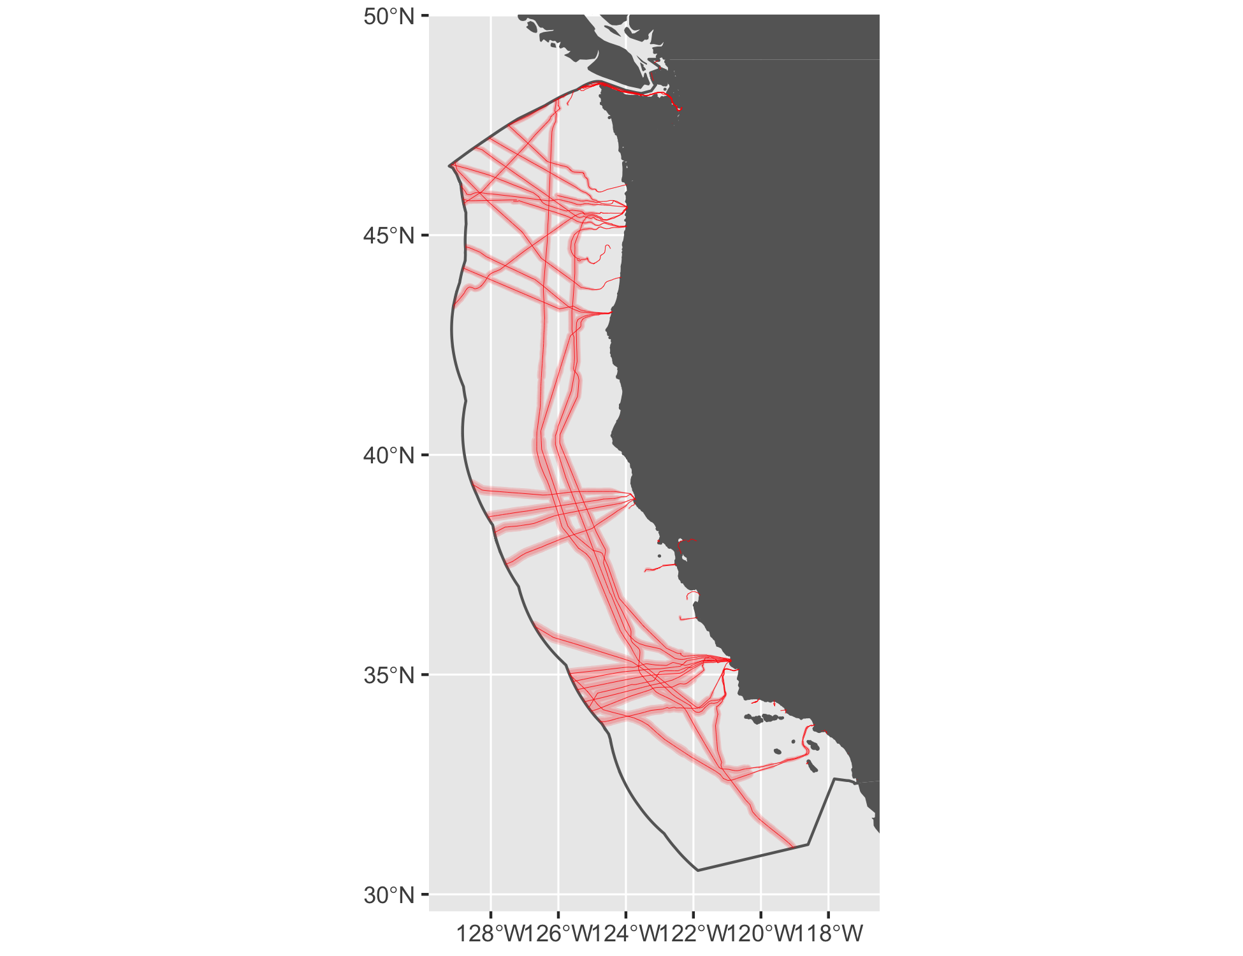

Figure 32 Cable buffers for West.

#### Tidal

See Figure 33.

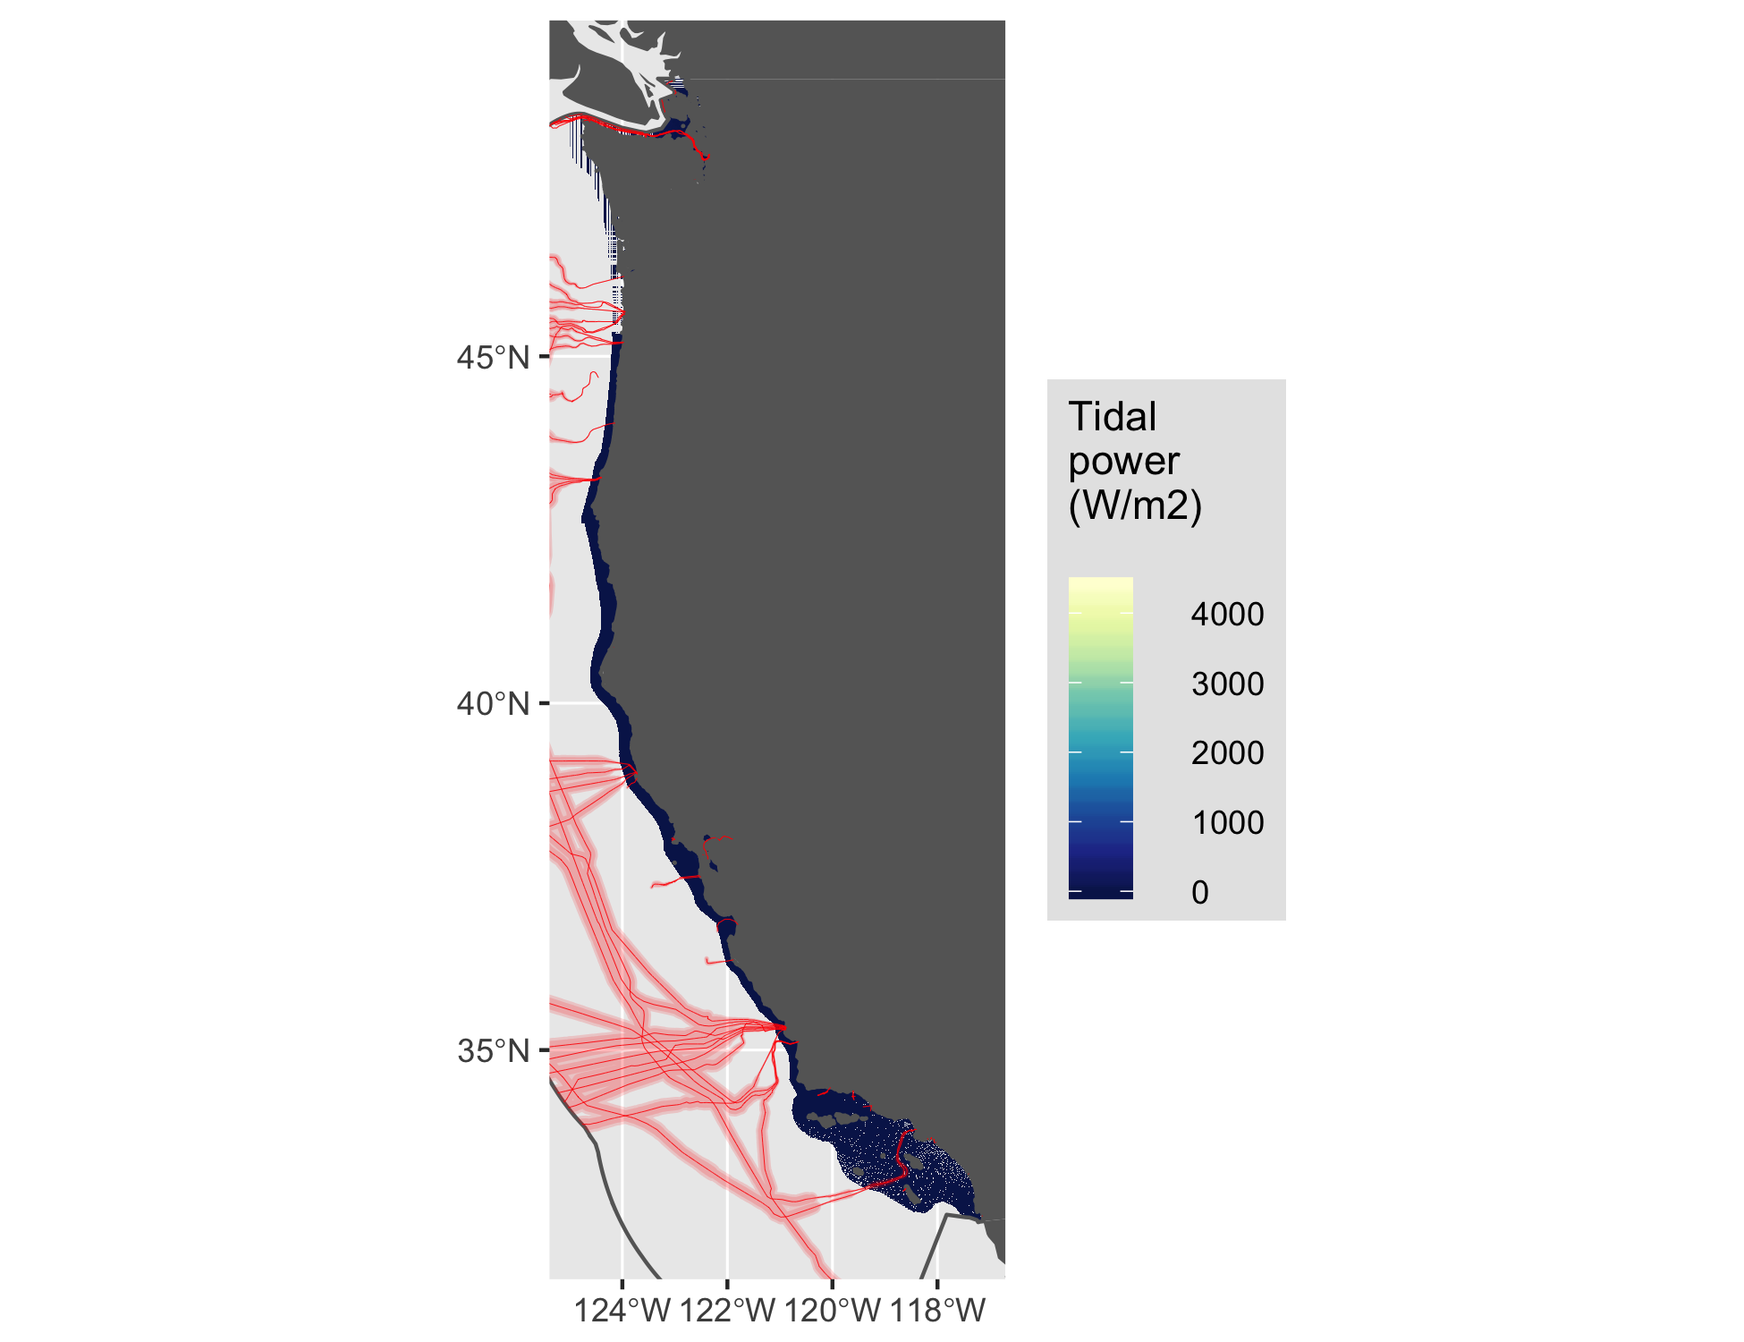

Figure 33 Tidal energy for West.

#### Wave

See Figure 34.

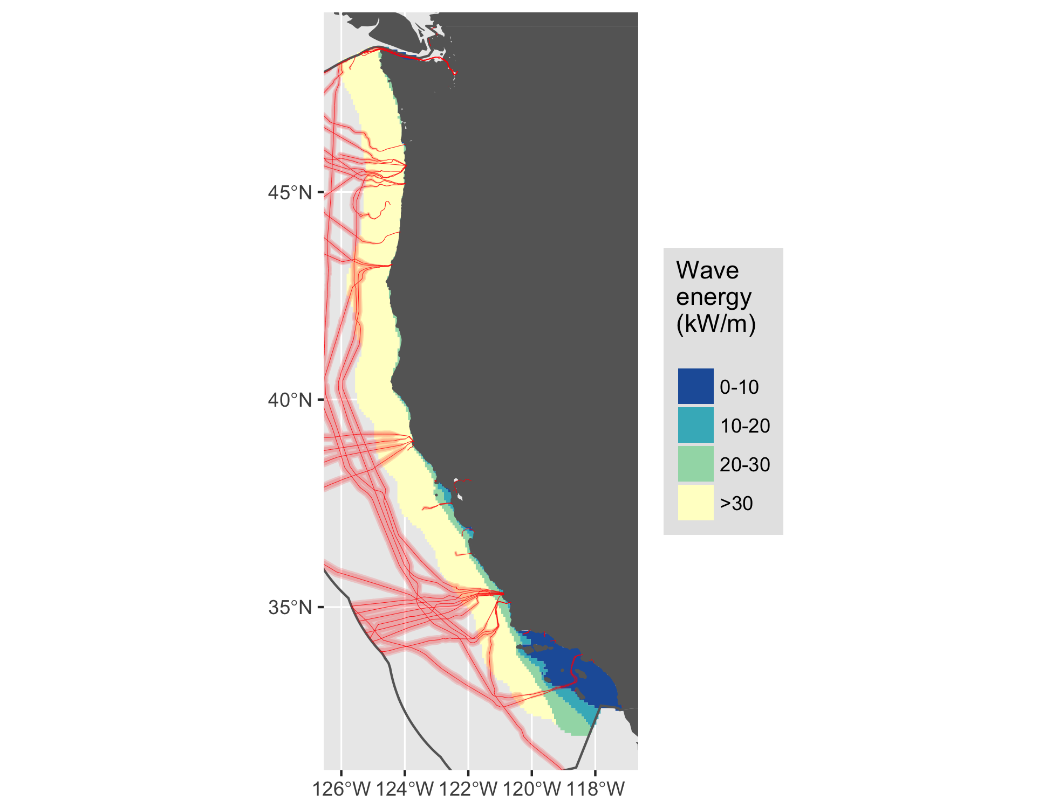

Figure 34 Wave energy for West.

#### Wind

See Figure 35.

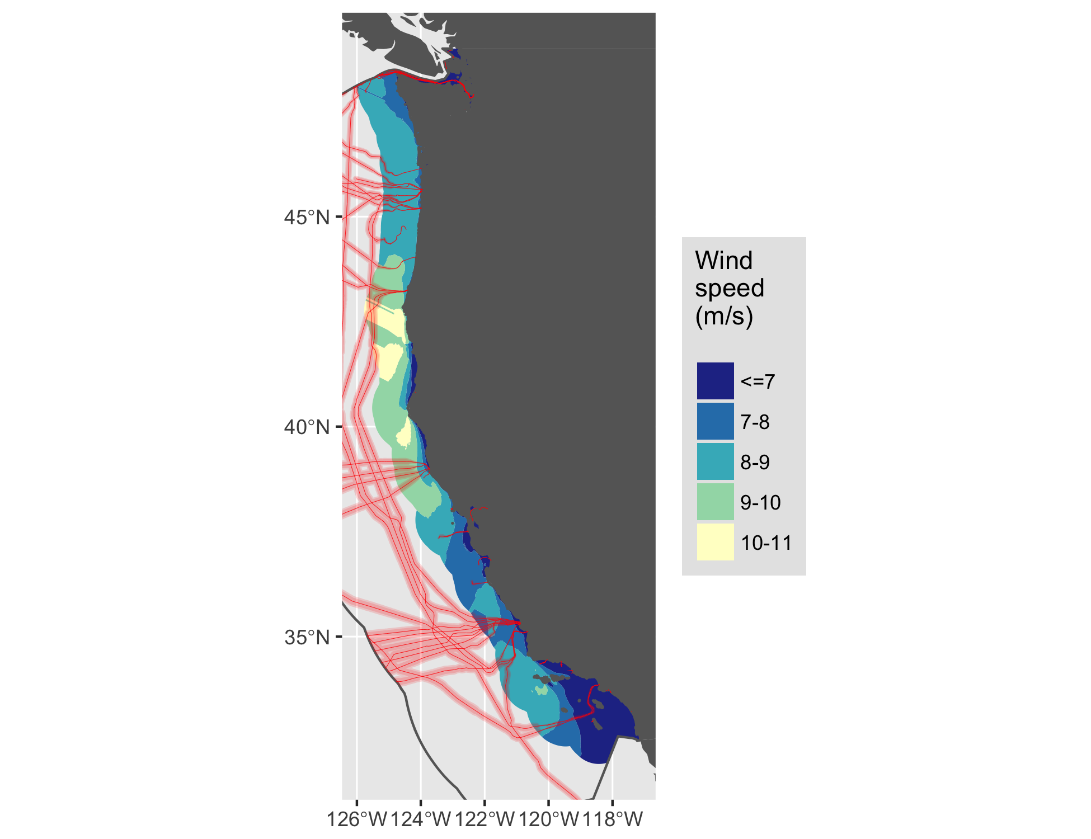

Figure 35 Wind energy for West.

# References

Amante, C., Kilcher, L., Roberts, B., & Draxl, C. (2016). *Offshore Cable Analysis: Pilot Study*.

Beiter, P., Musial, W., Kilcher, L., Maness, M., & Smith, A. (2017). *An Assessment of the Economic Potential of Offshore Wind in the United States from 2015 to 2030*. NREL (National Renewable Energy Laboratory (NREL), Golden, CO (United States)). <https://tethys.pnnl.gov/sites/default/files/publications/Beiter-et-al-2017-NETL.pdf>

Chapman, J., Lantz, E., Denholm, P., Felker, F., Heath, G., Mai, T., & Tegen, S. (2012). "Wind Energy Technologies," Chapter 11. National Renewable Energy Laboratory. Renewable Electricity Futures Study, Vol. 2, Golden, CO: National Renewable Energy Laboratory; pp. 11-1 – 11-63.

Communications Security, Reliability and Interoperability Council IV. (2014). *Protection of Submarine Cables Through Spatial Separation*. <http://transition.fcc.gov/pshs/advisory/csric4/CSRIC_IV_WG8_Report1_3Dec2014.pdf>

Communications Security, Reliability and Interoperability Council IV. (2016). *Clustering of Cables and Cable Landings*.

Flanders Marine Institute. (2016). Maritime Boundaries Geodatabase: Maritime Boundaries and Exclusive Economic Zones (200NM), version 9. <http://www.marineregions.org/>. Accessed 25 April 2017

Haas, K. A., Fritz, H. M., French, S. P., Smith, B. T., & Neary, V. (2011). *Assessment of energy production potential from tidal streams in the United States*. Georgia Tech Research Corporation, Atlanta, GA (United States). <https://www.osti.gov/scitech/servlets/purl/1219367>

Jacobson, P. T., Hagerman, G., & Scott, G. (2011). *Mapping and Assessment of the United States Ocean Wave Energy Resource*. <http://www.osti.gov/scitech/servlets/purl/1060943>

Lehmann, M., Karimpour, F., Goudey, C. A., Jacobson, P. T., & Alam, M.-R. (2017). Ocean wave energy in the United States: Current status and future perspectives. *Renewable and Sustainable Energy Reviews*. <http://www.sciencedirect.com/science/article/pii/S1364032116308164>

Musial, W., Heimiller, D., Beiter, P., Scott, G., & Draxl, C. (2016). 2016 Offshore Wind Energy Resource Assessment for the United States. NREL (National Renewable Energy Laboratory (NREL), Golden, CO (United States)). Retrieved from http://www.nrel.gov/docs/fy16osti/66599.pdf

Pachauri, R. K., Mayer, L., & Intergovernmental Panel on Climate Change (Eds.). (2015). *Climate change 2014: Synthesis report*. Geneva, Switzerland: Intergovernmental Panel on Climate Change.

Uihlein, A., & Magagna, D. (2016). Wave and tidal current energy review of the current state of research beyond technology. *Renewable and Sustainable Energy Reviews*, *58*, 1070–1081. <http://www.sciencedirect.com/science/article/pii/S1364032115016676>

US Dept of Energy, & US Dept of Interior. (2016). National Offshore Wind Strategy: Facilitating the Development of the Offshore Wind Industry in the US-Speaker-Alana Duerr.

VLIZ. (2017). IHO Sea Areas, version 2. VLIZ. <http://www.marineregions.org/>. Accessed 2 July 2017

1. NREL Wind Prospector: <https://maps.nrel.gov/wind-prospector/>
2. NREL MHK Atlas: <https://maps.nrel.gov/mhk-atlas>
3. North American Submarine Cable Association (NASCA): <https://www.n-a-s-c-a.org>
4. MarineCadastre.gov cable metadata: <https://coast.noaa.gov/dataservices/Metadata/TransformMetadata?u=https://coast.noaa.gov/data/Documents/Metadata/harvest/MarineCadastre/NOAAChartedSubmarineCables.xml&f=html>
5. GEBCO_2014 Grid, version 20150318, www.gebco.net
6. NREL Wind Prospector: <https://maps.nrel.gov/wind-prospector/>
7. NREL MHK Atlas: <https://maps.nrel.gov/mhk-atlas>
8. Wind data for 90-meter offshore: <http://www.nrel.gov/gis/data_wind.html>
9. The "one-sixth rule" for Albers Equal Area Conic projection: <http://desktop.arcgis.com/en/arcmap/latest/map/projections/albers-equal-area-conic.htm#GUID-2158C4F9-F197-458E-94F0-84933C1BE6B7>